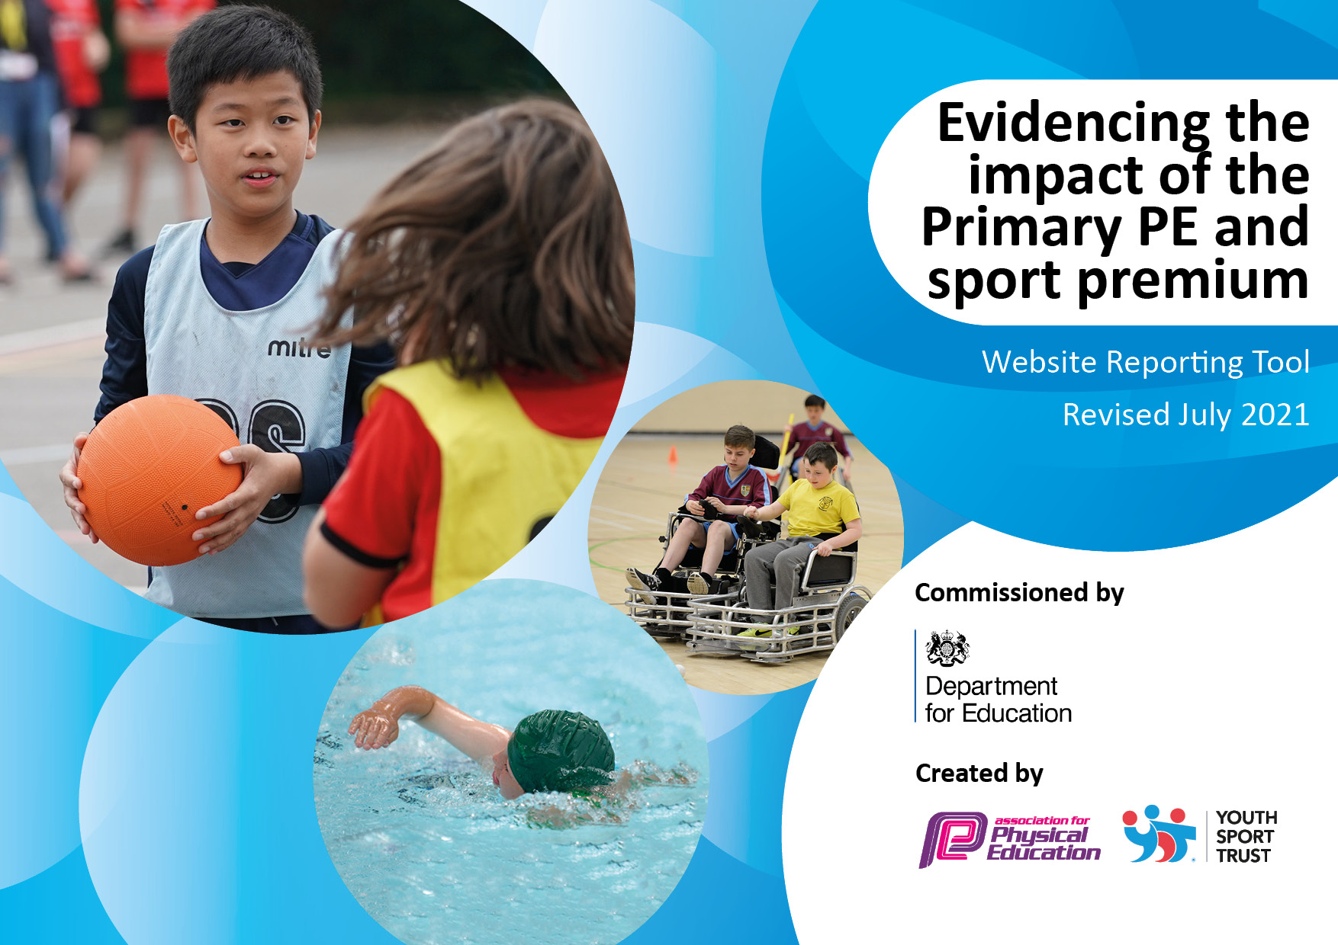
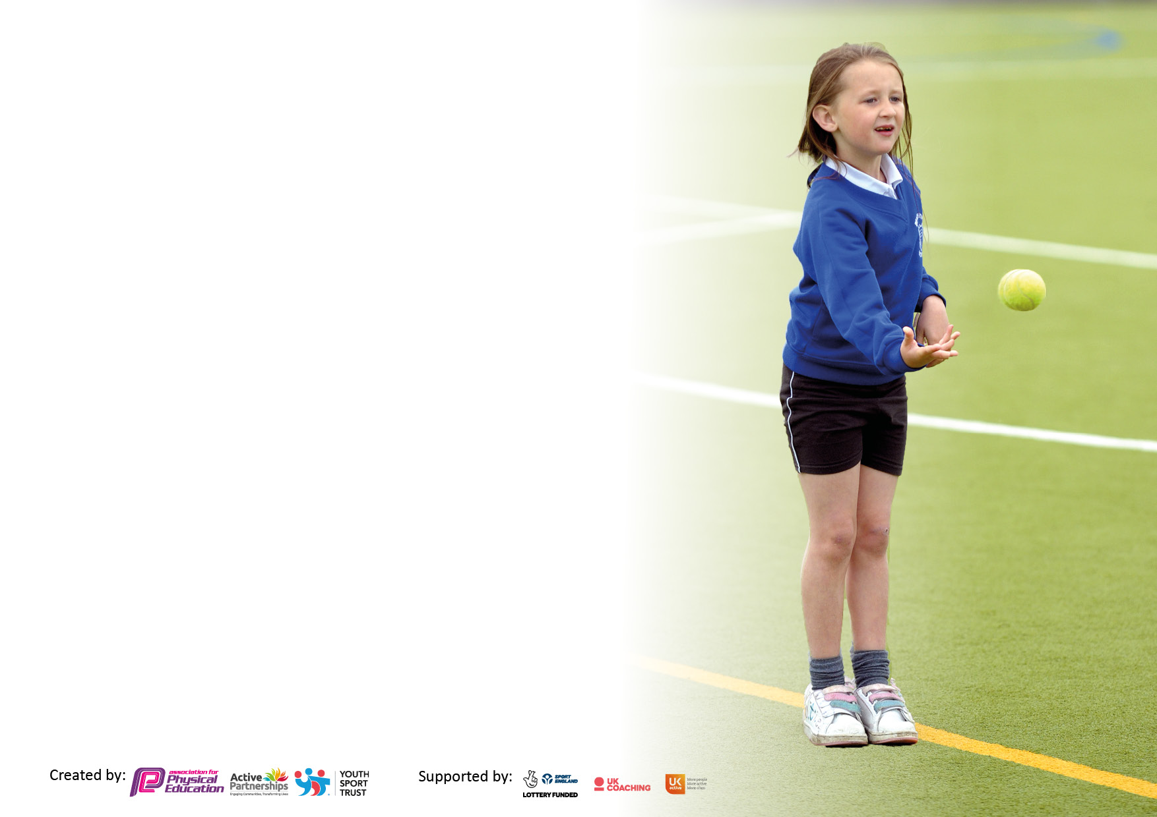

It is important that your grant is used effectively and based on school need. The Education Inspection Framework makes clear there will be a focus on ‘whether leaders and those responsible for governors all understand their respective roles and perform these in a way that enhances the effectiveness of the school’.

Under the Quality of Education Ofsted inspectors consider:
Intent - Curriculum design, coverage and appropriateness
Implementation - Curriculum delivery, Teaching (pedagogy) and Assessment
Impact - Attainment and progress

To assist schools with common transferable language this template has been developed to utilise the same three headings which should make your plans easily transferable between working documents.

Schools must use the funding to make additional and sustainable improvements to the quality of Physical Education, School Sport and Physical Activity (PESSPA) they offer. This means that you should use the Primary PE and sport premium to:

- Develop or add to the PESSPA activities that your school already offer
- Build capacity and capability within the school to ensure that improvements made now will benefit pupils joining the school in future years
- The Primary PE and sport premium should not be used to fund capital spend projects; the school’s budget should fund these.

Pleasevisitgov.ukfortherevisedDfEguidanceincludingthe5keyindicatorsacrosswhichschoolsshoulddemonstrate animprovement.Thisdocumentwillhelpyoutoreviewyourprovisionandtoreportyourspend.DfEencouragesschools to use this template as an effective way of meeting the reporting requirements of the Primary PE and sport premium.

We recommend you start by reflecting on the impact of current provision and reviewing the previous spend.

Schools are required to publish details of how they spend this funding, including any under-spend from 2019/2020, as well as on the impact it has on pupils’ PE and sport participation and attainment. All funding must be spent by 31st July 2022.

We recommend regularly updating the table and publishing it on your website throughout the year. This evidences your ongoing self-evaluation of how you are using the funding to secure maximum, sustainable impact. Final copy must be posted on your website by the end of the academic year and no later than the 31st July 2021. To see an example of how to complete the table please click HERE.
Created by: Supported by:

Details with regard to funding
Please complete the table below.

How much (if any) do you intend to carry over from this total fund into 2021/22? | £
Total amount allocated for 2021/22 | £19,000
Total amount of funding for 2021/22. To be spent and reported on by 31st July 2022. | £
Swimming Data
Please report on your Swimming Data below.

Meeting national curriculum requirements for swimming and water safety.

N.B. Complete this section to your best ability. For example you might have practised safe self-rescue techniques on dry land which you can then transfer to the pool when school swimming restarts.
Due to exceptional circumstances priority should be given to ensuring that pupils can perform safe self rescue even if they do not fully meet the first two requirements of the NC programme of study
What percentage of your current Year 6 cohort swim competently, confidently and proficiently over a distance of at least 25 metres?  N.B. Even though your pupils may swim in another year please report on their attainment on leaving primary school at the end of the summer term 2021.  Please see note above | 95%
What percentage of your current Year 6 cohort use a range of strokes effectively [for example, front crawl, backstroke and breaststroke]?  Please see note above | 39%
What percentage of your current Year 6 cohort perform safe self-rescue in different water-based situations? | 77%
Schools can choose to use the Primary PE and sport premium to provide additional provision for swimming but this must be for activity over and above the national curriculum requirements. Have you used it in this way? | No

Action Plan and Budget Tracking
Capture your intended annual spend against the 5 key indicators. Clarify the success criteria and evidence of impact that you intend to measure to evaluate for pupils today and for the future.

Academic Year: 2020/21 | Total fund allocated: | Date Updated:
Key indicator 1: The engagement of all pupils in regular physical activity – Chief Medical Officers guidelines recommend that primary school pupils undertake at least 30 minutes of physical activity a day in school |  |  |  | Percentage of total allocation:
 |  |  |  | %
Intent | Implementation |  | Impact
Your school focus should be clear what you want the pupils to know and be able to do and about  what they need to learn and to  consolidate through practice: | Make sure your actions to achieve are linked to your intentions: | Funding allocated: | Evidence of impact: what do pupils now know and what can they now do? What has changed?: | Sustainability and suggested next steps:
All children to complete two hours of high quality PE sessions per week.  Enhance playtime provisions  Golden mile continued  Challenge the more able/ G&A pupils with specialised support  Increased participation of EYFS and KS1 children in physical activity during break and lunch times  Audit of PE equipment  We Are Adventurers Forest school bought in for every year group | Attendance list from clubs  Lunchtime clubs for all children  Golden mile for all children  After school clubs for all children in Years 1-6. 3 clubs a week, which change half-termly.  Provide training for LO’s  Enhance playtime/ lunchtime equipment.  Sport Coach to introduce and run golden mile with all KS2 children.  Every child to be timed regularly.  Sport coach to monitor children’s progress and fitness levels  Whole school assembly  Medals and certificates to be ordered and given out as children achieve their own personal targets.  Teachers to supplement this with one half-hour golden mile run per week. Track using ipads  Update G and T list  Identify ‘target’ children  Sports coach to provide children with appropriate provisions.  Timetables of provision to be established. Sports Leaders to lead intra-schools league during the last week of every term  Purchase bikes, trikes and scooters for timetabled provision during break and lunch  Staff will have a better understanding of what equipment the school has and where it is located with a checking out system in place  ‘We Are Adventurers’ Forest school bought in for regular EYFS class sessions | £9570 for lunchtime clubs and £3780 for after school clubs.  £ 500  £None  £1000  £500 for new athletics/PE equipment  £3,750 | Annual impact report from Premier Sports showing increased percentages of children achieving Expected, Exceeding and Excelling throughout the year. *See appendix A for data  Enhanced range of resources purchased for use on the playground for lunchtimes to ensure that children are engaged in purposeful activities, continue to develop Fundamental skills through activities provided and are active for the majority of the time when outside. Increased participation in physical activity by KS1 and KS2.  Encouraging children to be actively fit for 30mins  Increase fitness levels of all children- children completing the mile in a faster time.  Improved weight/ height data  Provision mapping results- each group to make progress  Data and reports from Premier Sports. *See Appendix B for data showing BLM measure and increased distance for all year groups.  Increased fitness/balance and agility levels  Increased opportunity to practise and learn new athletics skills using suitable equipment  *See Appendix C for impact report showing improved respect, teamwork, creative thinking and more active children | Use data to target disengaged children during lunchtime clubs. Track impact.  LO will be trained to provide provisions once trained.  Low maintenance  Continue with LO and teachers and ask sports leaders to time children.  Use 2022-2023 SP allocation to pay a paint mile track or footprints on the playground  Use 2022-2023 SP allocation to pay a paint company to paint a track in EYFs and KS1 for the bikes/trikes/scooters  To continue next year.
Key indicator 2: The profile of PESSPA being raised across the school as a tool for whole school improvement |  |  |  | Percentage of total allocation:
 |  |  |  | %
Intent | Implementation |  | Impact
Your school focus should be clear what you want the pupils to know and be able to do and about  what they need to learn and to  consolidate through practice: | Make sure your actions to achieve are linked to your intentions: | Funding allocated: | Evidence of impact: what do pupils now know and what can they now do? What has changed?: | Sustainability and suggested next steps:
Continue of the focus on PE and Sport  Positive behaviour and a sense of fair play  Raise the awareness of leading a healthy and active lifestyle to all pupils. Sports council leaders to lead on this.  Continue to raise the profile of PE and sport across the school  Establish and embed an assessment strategy- indoor PE/gymnastics lessons  Continue to raise profile of PE and sport to raise fitness and well-being levels | Whole school focus through sports events and intra school competitions.  PE and sport opportunities offered to all pupils.  Whole school assemblies by school nurse and health and wellbeing professional.  Healthy eating and lifestyle workshops for parents.  Whole school cross-curricular Dance workshops for world book day.  Healthy active lifestyles in Science lessons.  Sports Day with medals for competitors  PE planning and assessment tool bought in from the iMoves company and embedded throughout the school. Staff training needed and AJ to monitor regularly  Lunchtime clubs for all children  Golden mile for all children  After school clubs for all children in Years 1-6. 3 clubs a week, which changes half-termly. | £9570 for lunchtime clubs and £3780 for after school clubs.  £free  £997 for iMoves subscription  £997 for iMoves subscription  £9570 for lunchtime clubs | Feedback from staff via the sports council.  Improved weight/ height data  PE and Sport is at the heart of Park View  Children have had great awareness of expectations and how to develop. Increased differentiations and creativity in lessons has led to enjoyment across the curriculum.  Use the website to share information with parents.  Increased number of children understanding the importance of leading a healthy, active lifestyle.  PE and Sports blog to show children’s achievements  Photos, feedback from parents and children.  SSG award  All staff have a better understanding of how games, dance and gymnastics are taught across the school. Staff training from iMoves in September 2022. Teachers will be able to identify and address gaps in teaching and learning  Registers  Golden mile data (Appendix B)  Impact report (Appendix A) | Continuation of sports council  Continue focus on active travel  Carry on using iMoves for planning, delivery and assessment of dance and gymnastics lessons in 2022-2023  Carry on using iMoves for planning, delivery and assessment of dance and gymnastics lessons in 2022-2023

Key indicator 3: Increased confidence, knowledge and skills of all staff in teaching PE and sport |  |  |  | Percentage of total allocation:
 |  |  |  | %
Intent | Implementation |  | Impact
Your school focus should be clear | Make sure your actions to | Funding | Evidence of impact: what do | Sustainability and suggested
what you want the pupils to know | achieve are linked to your | allocated: | pupils now know and what | next steps:
and be able to do and about | intentions: |  | can they now do? What has
what they need to learn and to |  |  | changed?:
consolidate through practice:
Continued focus on quality of T&L in PE after audit of need and external lesson observations to ensure HA outcomes in PE  Continue focus on lunchtime and after school provisions | Premier Sports leader to be brought in to provide one to one curriculum support to coaches following lesson observations.  External QA lesson observations by Manchester Active Schools x3 annually (Not done because of COVID)  T.A. staff to observe Premier Sports lessons and use this to team teach in other PE lessons, including dance and gymnastics | £150 (Not done because of COVID) | Outstanding lesson observations- lesson observation sheets.  Data tracking registers from Premier Sports (appendix A)  100% engagement and participation in PE  Assessments to show progress.  Coaching observation and feedback sheets  Registers of participation. Tracking evidence | Teachers to support learning of parallel classes- children and teachers in areas of support been given.  That sports continues and rolls into 2022-2023
Key indicator 4: Broader experience of a range of sports and activities offered to all pupils |  |  |  | Percentage of total allocation:
Intent | Implementation |  | Impact
Your school focus should be clear | Make sure your actions to | Funding | Evidence of impact: what do | Sustainability and suggested
what you want the pupils to know | achieve are linked to your | allocated: | pupils now know and what | next steps:
and be able to do and about | intentions: |  | can they now do? What has
what they need to learn and to |  |  | changed?:
consolidate through practice:
Continue to provide High Quality After-School Sporting Sessions in more range of different sports, which change every half-term  Continue to provide High Quality Lunch Time Sporting Sessions in a variety of different sports, which change every half-term.  We Are Adventurers Forest school bought in for every year group | Pupil voice on what after school clubs and lunchtime clubs the children would like to participate in.  Sports coach to be used every day at lunch to ensure all children are given the opportunity to participate in extra curricular clubs weekly.  We Are Adventurers Forest school bought in for regular EYFS class sessions | £9570 for lunchtime clubs and £3780 for after school clubs.  £3750 | % Of children participating in extra curricular activities increased. See registers in appendix. A  Photos on blogs and websites  Pupil voice evidence registers  *See Appendix C for impact report showing improved respect, teamwork, creative thinking and more active children | Lunch time organisers will observe PE coaches and repeat their activities throughout the week

Key indicator 5: Increased participation in competitive sport |  |  |  | Percentage of total allocation:
 |  |  |  | %
Intent | Implementation |  | Impact
Your school focus should be clear | Make sure your actions to | Funding | Evidence of impact: what do | Sustainability and suggested
what you want the pupils to know | achieve are linked to your | allocated: | pupils now know and what | next steps:
and be able to do and about | intentions: |  | can they now do? What has
what they need to learn and to |  |  | changed?:
consolidate through practice:
Continue to develop physical abilities in targeted children- G & T, Less Able, Less Active  Continue to increased participation in intra year group competition Level1  Increased participation of KS2 children level 2 competitions.  More B and C teams entering competitions.  Continue to develop physical abilities in targeted children- G & T, Less Able, Less Active  Continued participation in level 2 and level 3 intra school competitions. | Extra curricular clubs set up to develop the fitness and physical ability of targeted children  2 sessions per week KS2  1 sessions per week KS1  Sports coach to set up Level 1 competitions during PE lessons  Enter children into the competitions on the manchesterschoolspe.co.uk website  Arrange for transport and parental consent  Select the appropriate staff of attending the events  Select competitions bases on MCA clubs and additional clubs  Sports Leaders to lead intra-school sports league during the last week of every term  Subscription to Manchester Schools PE association membership | £3780 for after school clubs  £825 for Manchester PE association membership (21-22)  £90 for taxi trips to inter-school competitions.  £825 for Manchester PE association membership (21-22) | Registers and photographs.  Increased number of children participating in competitive sports. (Minimal impact due to continued COVID restrictions in Autumn term)  Registers  Record the scores and photograph for evidence  Support for all aspects on PE and school support. Organisation of competitions  Track participation in registers and results, scores and tables.  Enter intra-school competitions and receive support from MSPEA | Continue to develop physical abilities in targeted children- G & T, Less Able, Less Active  Continue to increased participation in intra year group competition Level1  Re-engaging with SSG Mark for next year (22-23) to retain silver status  Increased participation of KS2 children level 2 competitions.  More B and C teams entering competitions.  Continue to develop physical abilities in targeted children- G & T, Less Able, Less Active  Continued participation in level 2 and level 3 intra school competitions.

Signed off by
Head Teacher: | Sarah Navin
Date: | 27/7/22
Subject Leader: | Arwel Jones
Date: | 27/7/22
Governor:
Date:

