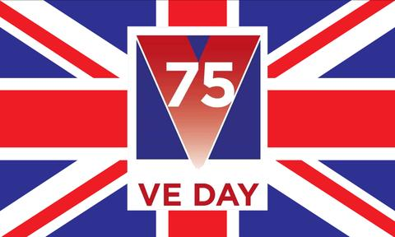

Wear red, white and blue

on Friday 8th May

**Research WW2 ending**

• What does VE Day stand for? • What and who are we remembering? • When was the first VE day? • What were the events leading up to it? • How did the people of Britain react? • What did people do to celebrate the first VE day? Create a fact-file, poster or information booklet.

Useful website: <https://www.bbc.co.uk/newsround/48201749>

**VE Day**

Family Activities

**VE Day Party**

Why not plan and hold your own party at home. Decorate your house or garden in red, white and blue and sing some songs that were heard on VE Day 75 years ago.

**WE’LL MEET AGAIN**

We’ll meet again We’ll meet again, Don’t know where, Don’t know when But I know we’ll meet again some sunny day Keep smiling through, Just like you always do Till the blue skies drive the dark clouds far away So will you please say “Hello” To the folks that I know Tell them I won’t be long They’ll be happy to know That as you saw me go I was singing this song We’ll meet again, Don’t know where, Don’t know when But I know we’ll meet again some sunny day

**The National Anthem:** <https://www.youtube.com/watch?v=nZY8H3MwKz4&feature=emb_logo>

**Creative Learning Ideas**

Design a special VE day medal Draw, sketch or paint to create VE day inspired artwork Listen to some 1940’s music and create a dance or copy one already in existence Make a Union Jack flag

**ideas and resources**

BBC History KS2: VE Day class clip: <https://www.bbc.co.uk/teach/class-clips-video/history-ks2-ve-day/z7xtmfr>

1. Create your own speech as if you are Winston Churchill declaring the news (remember the types of persuasive language that need to go in a speech). Watch his speech to see what it was like: <https://www.youtube.com/watch?v=NEavcsrMoMw> Look at persuasive writing techniques <https://youtu.be/Mlka2xBvV5Q> 2. Create a VE day poem or an acrostic poem 3. Make a PowerPoint about the 75th VE Day and why it is special 4 Try your hand at cracking the code with these resources from Bletchley Park. <https://bletchleypark.org.uk/cms/2020/04/ACTIVITIES.pdf> 5. Try the Newsround VE Day quiz: <http://news.bbc.co.uk/cbbcnews/hi/newsid_4520000/newsid_4523900/4523967.stm>

**Wartime Recipes**

Have a go at some wartime meals: [**https://the1940sexperiment.com/100-wartime-recipes/**](https://the1940sexperiment.com/100-wartime-recipes/)

**T**ry this recipe from Winston Churchill’s very own cook: **CHURCHILL’S SWISS ROLL 130g caster sugar plus extra 3 eggs 85g plain flour 1/2 tsp baking flour Strawberry or Raspberry Jam**

**Beat the eggs and sugar together for 5 minutes. Sift in the flour and baking powder. Grease and line an oblong baking sheet and spread over the** mixture. Bake in a very hot oven (180ºc) for 8 minutes. Turn immediately on to some sugared paper, trim edges. Spread with hot jam and roll up.