SEND POLICY

March 2024

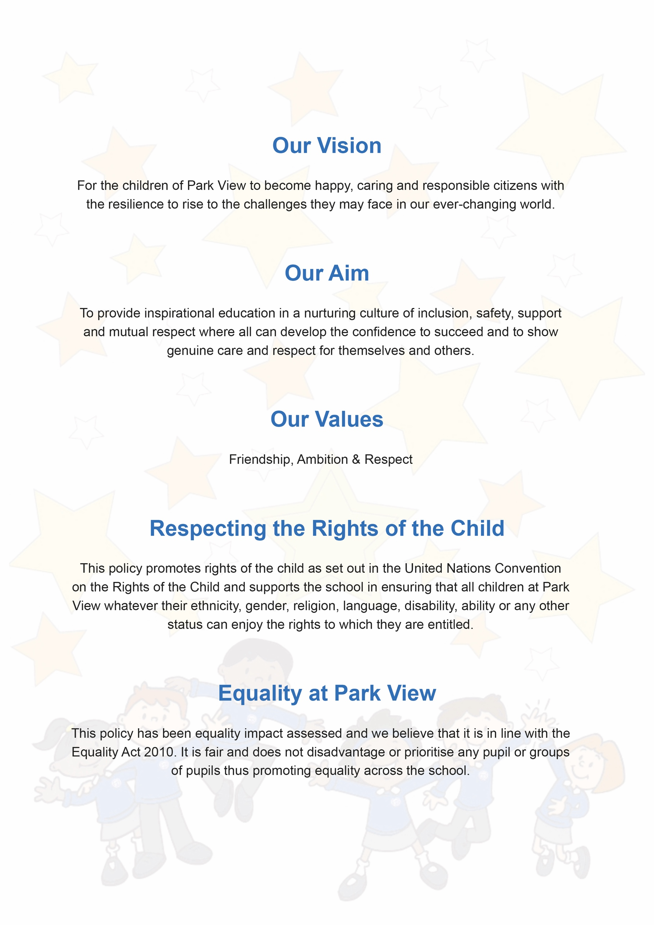

SEND Policy

Document Control
Title | SEND Policy
Purpose | To explain the legal definition of SEND. As well as the school approach to identifying, assessing and meeting the needs of pupils with SEND
Supersedes
Amendments
Related Policies/Guidance | SEN Information Report (updated annually), Behaviour Policy, Supporting Pupils with Medical Conditions Policy
Author | Sophie Murfin
Approved Level | Governing Body – Statutory Policy
Date adopted | 25th March 2024
Expires | March 2025
Signature of Chair
Park View Community Primary School
Varley Street
Manchester
M40 7EJ

Park View Community Primary School has a number of policies which are adopted to ensure an equitable and consistent delivery of provision.

Within our policies reference to:
- Governing Body/Governors relate to the members of the Local Governing Body.
- School includes a reference to school or school unless otherwise stated.
- Headteacher includes a reference to Headteacher, Principal or Head of School of a school.

Contents
1. Aims 4
2. Definitions 4
3. Roles & Responsibilities 4
4. Identification & Assessment of SEN 5
5. Reviewing 6
6. Policy Links 6
7. Leadership 6
8. Complaints Procedures 7

- Aims

At Park View Community Primary School we have an ethos that every child matters and that we set goals that stretch and challenge pupils of all backgrounds, abilities and dispositions. Our support for all children within our care extends to those children with additional needs that require assistance to help them fulfil their potential.

At Park View Community Primary School we shall ensure that:

- the special educational needs of pupils will be addressed and pupils will not be labelled or disadvantaged by any policy or procedure operated within the Trust;
- it works in partnership with parents and appropriate external agencies to support students with special educational needs and will use its best endeavours to ensure that appropriate provision is secured for any student with special educational needs in order to achieve agreed outcomes;
- it has a Special Educational Needs Co-ordinator (SENCO). The SENCO will maintain and regularly review the SEN record held in respective of an individual pupil and co-ordinate support. However, it will be the responsibility of all staff to support individual pupils, to implement strategies suggested by the SENCO and generally be responsible for ensuring that pupils receive provision appropriate to their needs and agreed outcomes; and
- children and young people with SEN engage in the activities of the school alongside pupils who do not have SEN

All support provided and decisions taken have regard to these general principles as well as the legal framework set out in the Children & Families Act 2014, the SEND Regulations 2014 and the SEND Code of Practice 2015.
- Definitions

Under the Children & Families Act 2014, a child/young person will have SEN if they have a learning difficulty or disability which calls for special educational provision to be made for them.

A Child or Young Person will have a learning difficulty or disability if they have:

- A significantly greater difficulty in learning than the majority of others of the same age; or
- A disability that prevents or hinders them from making use of facilities that are generally provided for others of the same age in mainstream schools in England.

Special Educational Provision is education or training that is additional to, or different from, that made generally for other children/young people of the same age by mainstream schools
- Roles & Responsibilities

The implementation of this policy will be monitored by the governors of the school and remain under constant review by the Headteacher.

- Park View Community Primary School will appoint a governor with responsibility for SEN. The SEN Governor will raise SEN issues at governing board meetings; monitor the quality and effectiveness of SEN provision within the school and work with designated senior leaders to develop the SEN policy and provision.
- The Headteacher will work with the SENCO and SEND Governor to develop the SEND policy and provision within the school. The Headteacher has overall responsibility for the provision and progress of learners with SEND.
- The SENCO will co-ordinate the school’s approach to SEND provision and will undertake those duties set out in chapter 6 of the SEND Code of Practice 2015.
- Class teachers are responsible for the progress and development of every pupil in their class and will work with the SENCO to ensure the “assess plan do review” cycle is appropriately implemented to support any pupil with SEND.

The school will work in partnership with pupils, teachers, parents and, where appropriate, other external agencies to ensure that individual learning needs are addressed within the context of the school curriculum.

Parents of pupils with SEND will be able to discuss the needs of their child with their child’s teacher, the member of SLT overseeing the Key Stage and the SENCO.
- Identification & Assessment of SEN

The school uses the graduated response as outlined in “The Code of Practice (2014)”. Pupils who have been identified as potentially having additional needs are monitored using Cause for Concern forms, which forms part of the cycles of Assess, Plan, Do, Review. This process is further supported with the following approaches-

- First and foremost, High Quality Teaching approaches in the classroom underpinned by adaptive teaching and scaffolding and informed by the Inclusion Toolkit.
- Further diagnostic testing directed by the SENCO.
- Observations by staff
- Additional intervention as identified within Assess, Plan, Do, Review to provide support “additional to and different from” peers.
- Following this process, or in cases where significant need presents immediately, the SENCO may then ask for additional diagnostic assessment to be undertaken by other professionals e.g. Educational Psychologists, CAMHS, Speech and Language Therapy, School Health Nurse, Outreach Support.

Information about previous special educational needs will usually accompany pupils upon entry to the school and this will be used by the SENCO to make sure appropriate provision is continued. New admissions with identified SEND needs will be transitioned in with the support of the SENCO.

This information is collated from the transfer of school files from the previous school or early years setting and during transition meetings which are held with all the feeder schools or early years settings, in the summer term, before students start at the school. If there is an in-year transfer, the same procedures will be followed. If the pupil has an Individual Education Plan, SEN Support Plan or EHCP in place, close consultation will occur, to ensure a smooth transition and continuity in targets, provision and expected outcomes.

Ongoing identification is also completed alongside the school reporting process as data is collected and analysed by phase leads. If a pupil has not made expected progress, then interventions or boosters will be put in place regardless of need. If a member of staff identifies a pupil whose special educational needs are not met by the normal programme of study, then the class teacher will work with the pupil setting clear targets and providing further scaffolding and supports. If the situation improves then no further action is needed. If there is no improvement the SENCO will be informed.

At this point information will be gathered. The class teacher will inform the parents about the issue and there will be consultation and discussion around the proposed additional support for the pupil. Parents, and the pupil, where appropriate, will be involved in sharing information and agreeing outcomes. It will be decided whether it is appropriate to further monitor the student. A detailed SEN Support plan with SMART targets will be collated, informed by any outcomes of diagnostic testing and outreach advice. These will be reviewed on a half termly basis.

If a parent/carer refers their child to the school as they believe their child has special educational needs they should contact the SENCO, who will undertake investigations and appropriate assessments (with input from the relevant teachers) to see if they are achieving expected levels of progress in line with their potential. If the pupil is not making appropriate levels of progress, then internal support will be implemented in accordance with paragraphs above.

In all cases, where internal support is not effective in supporting the pupil, a referral to the Educational Psychologist or other relevant specialist will be completed with the parents’ knowledge and information and strategies for support shared with all staff.

Contact details for professionals who are able to assess will be provided for parents/carers so they can consider a private assessment. Whenever special educational provision is being made, parents and students will be involved in developing and reviewing support plans/strategies.

All staff teaching pupils on the SEND register will be made aware of the individual needs. The SENCO and Senior Leadership Team will help teachers when required, to develop techniques in adapting and scaffolding lessons and will ensure that appropriate resources are available as part of the school’s CPD programme.

- Reviewing

The progress of all pupils is monitored and reviewed regularly, regardless of needs. Data collated during the academies’ reporting process is analysed and strategies are put in place to support pupils who are not achieving as expected. All SEND interventions delivered outside the classroom have Specific, Measurable, Achievable Targets (SMART) set to ensure that progress is made. These are recorded using SEN Support Plans and are monitored and reviewed against a time frame, agreed within the plan. If expected progress is not made, then the SENCO may refer to a specialist services such as an Educational Psychologist.

If a pupil has an Education Health Care Plan an annual review is held in accordance with legal requirements and a detailed provision map of Section F of the EHCP is followed by teaching staff.

If, as a result of appropriate progress, a pupil is removed from the SEND register, the pupil will continue to be monitored through the school’s assessment and reviewing processes
- Policy Links

This policy should be read in conjunction with:

- SEN Information Report (updated annually)
- Behaviour Policy
- Supporting Pupils with Medical Conditions Policy
- Leadership

SENCOs at Park View Community Primary School is:

- Mrs Janine Lewis

8. Complaints Procedures:

Initially, all complaints from parents or carers regarding their child's provision is made to the SENCO, who follows this up with relevant staff. However, if a parent or carer is not satisfied with the response given, the Complaints Procedure may be followed. This is outlined in our policy which is available on our website

