SEN REPORT

February 2024

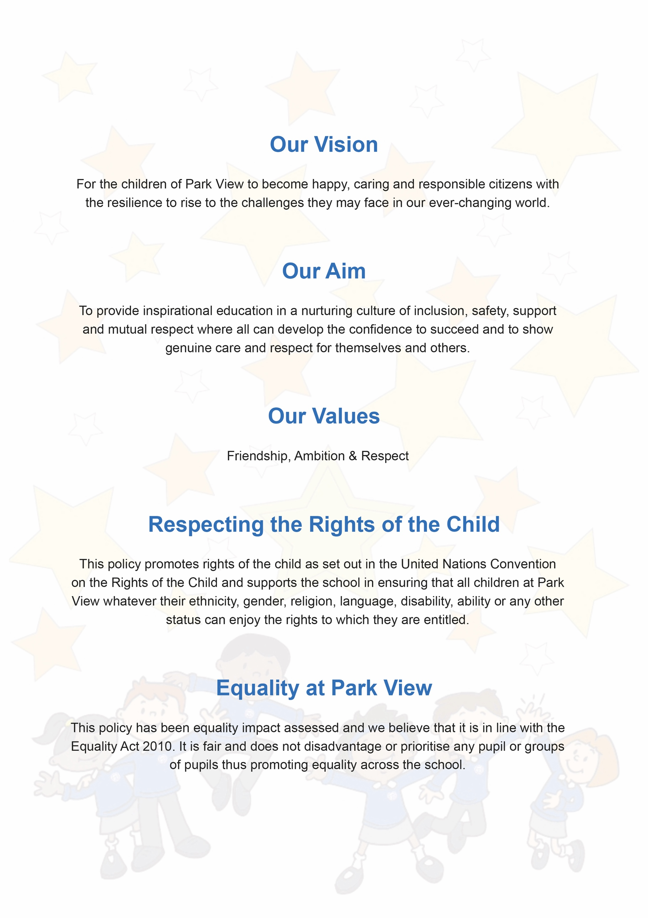

SEN Report: Park View Community School
Our job is to help your child achieve the very best they can at school. This report is to inform you of the types of support available for your child at Park View Community School. It will help you understand who can help and how this support can be accessed.
Our SENCO Team is:
Miss Lewis (SENDCO)
Mrs Musselle (Acting SENDCO)

The kinds of special educational needs and disabilities for which provision is made at Park View Community School
Park View Community School is a mainstream school which caters for children from 3–11 years old.
We have an inclusive ethos and aim to meet all children’s needs, supporting their development in the most appropriate way to ensure they reach their full potential.
The 0-25 SEND Code of Practice (2015) identifies 'four broad areas of Special Educational Need and support:
Communication and Interaction
We work collaboratively with our Speech and Language Therapist to rapidly identify needs and apply the relevant provision for each individual child. Our SENCO works with the Therapist to ensure that our dedicated Speech and Language Therapy Teaching Assistant can apply the necessary intervention. These include: Listening Skills, Construction Agents, Lego Therapy, Talk Boost, Mouth Gym and specific Speech and Language Therapist directed activities.
Cognition and Learning
We are able to offer a range of interventions designed to help children achieve their maximum potential e.g., Read Write Inc, 5-minute box, Write from the Start, Maths interventions, Pre-Teach sessions, BSP Auditory memory, Meemo and a variety of other targeted interventions. Training and support is given by appropriate professionals including the SENCO. Progress and impact is carefully monitored.
Social, Emotional and Mental Health (SEMH)
We utilise the Boxall Profile pupil wellbeing assessment tool to identify what structured and targeted support is needed for children experiencing SEMH difficulties. We have a number of tailored approaches for children in this area. Interventions alongside the Boxall Profile such as Rays of Sunshine, Volcano in my tummy, the Anxiety Gremlin/60 mindful minutes and Nurturing Emotional Development are in place from trained staff members.
Support for your child at Park View Community School
All pupils in school receive quality first teaching. This means that a range of teaching and learning styles are used and that appropriate learning objectives are set for all children with a curriculum matched to their needs.
Teaching and lessons are adapted to match the particular needs of the child in terms of activities, resources, teaching approaches and expectations. A range of techniques are used to scaffold learning and ongoing professional development to promote high quality teaching and adaptations are in place through our CPD offer. Effort as well as achievement is recognised in all areas of the curriculum.

All year groups in Foundation Stage and Key Stage One are supported by a teaching assistant. Teaching assistant support in Key Stage Two is targeted at particular groups of children and planned by the Class Teacher and Inclusion Lead.

Throughout the school, teaching assistant support is targeted at particular groups of children and planned by the Inclusion Lead.
Adaptations may be made to the curriculum for children with SEND. These can include adjusting the timetable and breaking lessons into more manageable chunks.
Park View identifies students with special educational needs in a number of ways:
- Liaison with previous setting
- Concerns/information received from teaching staff
- Concerns/information received from parents
- Assessments such as reading ages
- Teacher/Staff referral system

How do we measure the progress of children with SEND?
- Your child’s progress is continually monitored by his/her class teacher and is discussed formally each term with the Inclusion Team and yourself as part of the school's SEND Review weeks.
- All children when entering Reception, will have their progress measured using a baseline assessment. This will enable us to track your child’s progress through the year.
- If your child is in Year 1 and above, but is not yet at National Curriculum levels, their progress will be measured using the Pre Key Stage Standards, which shows their level in more detail and will also show smaller but significant steps of progress.
- At the end of each key stage (i.e. at the end of year 2 and year 6) all children are formally assessed using Standard Assessment Tests (SATs) and Teacher Assessment (TA). This is something that the government requires all schools to do and the results from these assessments are published nationally.
- Children identified as requiring ‘SEN support’ will have individual education targets. These targets are reviewed regularly and each term you will have the opportunity to meet with your child’s class teacher and/or Inclusion Lead to review the progress made and discuss plans for the following term.
- The progress of children with an EHC Plan is formally reviewed at an Annual Review and involves all the agencies that are a part of your child’s education
- The Inclusion Lead will also check that your child is making good progress within any individual work and in any group that they take part in by monitoring interventions.

How we Provide Support for SEN Bullying
The welfare of all pupils’ is of paramount importance. We recognise that some children may be especially vulnerable to abuse. We recognise that children who are abused or neglected may find it difficult to develop a sense of self-worth and to view the world in a positive way. We recognise that they may exhibit concerning behaviours and at times this may impact on other children either directly or indirectly. We will always take a considered and sensitive approach in order that we can support all of our pupils.
Children are encouraged to share concerns with their teacher or our inclusion team Miss Mehaffy, Mrs Brotherton, Mrs Musselle, Miss Dale and Mrs Ward-Ross.
SEN stages and terminology
The Special Educational Needs Code of Practice 2014 gives guidance to schools in meeting the needs of pupils. It sets out how help should be given in a step-by-step approach. You will be consulted at all stages of this graduated approach and staff will inform you of the additional work they do with your child.
Class teachers will assess your child to identify their strengths, needs and the extra help they require. They will discuss this with you and decide on next steps.
Education Health and Care Plan (EHCP)
If your child’s needs are complex or severe we may suggest that we ask the Local Authority for a Statutory Assessment. This document will describe your child’s SEN and the special help they should receive.
EHCP’s usually involve the Local Authority providing extra resources to help your child. These could include money, staff time, special equipment and attendance at a school with specialist resourced support. This additional provision will be reviewed annually or sooner if required and would include parent, teacher, Inclusion Lead and pupil.
Since September 2014, all children and young people from age 0-25, who have significant special educational needs will undergo an Education Health and Care (EHC) Assessment.
How will we support your child moving to a new class or moving on?
We recognise that transitions can be difficult for a child with SEND and take steps to ensure that any transition is as smooth as possible.
If your child is moving to another school:
- We will contact the school SENCO and ensure he/she knows about any special arrangements or support that needs to be made for your child.
- We will make sure that all records about your child are passed on as soon as possible.

When moving between classes at Park View:
Information will be passed on to the new class teacher IN ADVANCE and a planning meeting will take place with the new teacher. All One Page Profiles will be shared with the new teacher.

In Year 6:
- Transition to high school is planned on an individual basis with the high school and pupils / parents.
- Your child may do focused learning about aspects of transition to support their understanding of the changes ahead.
Who can help?
We have a highly experienced team of staff who may be involved in supporting your child at Park View. These include:
- Your child’s teacher, who will always make sure that tasks set are appropriate and accessible for your child. They are available to you at the start of each day and by appointment after school.
- Teaching Assistants, who support groups and individual children with their learning as well as whole classes when necessary.
- The Inclusion Lead (Miss Lewis) who co- ordinates the provision of SEND in school.
- Sometimes school may commission Specialist Support to work with identified children with a particular focus e.g. Speech and Language Therapists or Occupational Therapists.
Consulting with outside parties.
As part of our support for all children in school we have regular opportunities to consult with support services and health agencies through a multi-agency approach which sometimes includes completing an Early Help Assessment (EHA) to support the family as well as the pupil.
We will discuss the needs of the individual/family in school and plan together the best use of advice and support from other agencies.
Professionals who might attend this meeting include:
- Our School Nurse who works closely with us and can advise and assess any medical needs. If a care plan is required this would be done in conjunction with the parent/nurse and reviewed annually as a minimum.
- Our Speech and Language therapist may give advice or complete an assessment for a few children.
- Our Educational Psychologist may give advice or complete an assessment for a few children.
- Behaviour Support Professionals who give advice if required.
- Outreach support from specialist schools.
How are the teachers in school helped to work with children with SEND and what training do they have?
The Inclusion Lead and team support the class teacher in planning for children with SEND. The school provides training and support to enable all staff to improve the teaching and learning of all children, including those with SEND. This includes whole school training on SEND issues, such as Autism, Speech and Language Needs and Specific Learning disorders. Our Teaching Assistants are trained to deliver interventions such as RWI 1:1.
What activities are available for children with SEND in addition to those available in accordance with the curriculum:
- All extra-curricular activities are available to all our children
- Our residential trip is available to all our children
- All our children play on the playground together at lunch and break times
Consulting pupils about SEND
Children take part in a pupil voice activity annually. Their views and those of parents are recorded termly at SEND review meetings. The children contribute to their One Page Profiles.
What arrangements do we have for dealing with complaints about the provision for children with SEND?
It is in everyone’s interests for complaints to be resolved as quickly and at as low a level as possible and our complaints procedure is as follows:
In the first instance please contact the class teacher if there is anything that you are concerned about or the Inclusion Lead depending upon the nature of your worry.
If the matter cannot be resolved please contact the Head teacher, Ms Navin on 0161 519 8562 to arrange an appointment. She will investigate your concern and report back to you. If, having taken the above action, you are not satisfied by the outcome, you can raise your concern in writing to Mrs Kinch, Chair of Governors via the school.
Parents can also contact the Information and Advice Service by phone on 0161 209 8356 or by emailing parents@manchester.gov.uk.
If you would like to know what provision is in place for your child or if you have any concerns that your child has some additional needs please speak to your child’s class teacher.
You are also very welcome to make an appointment with our Inclusion Lead, Miss Lewis.
Appointments can be made through the school office (0161 519 8562). Further information can be found on the school’s website regarding policies and school events.

