Accessibility Policy and Plan

November 2023

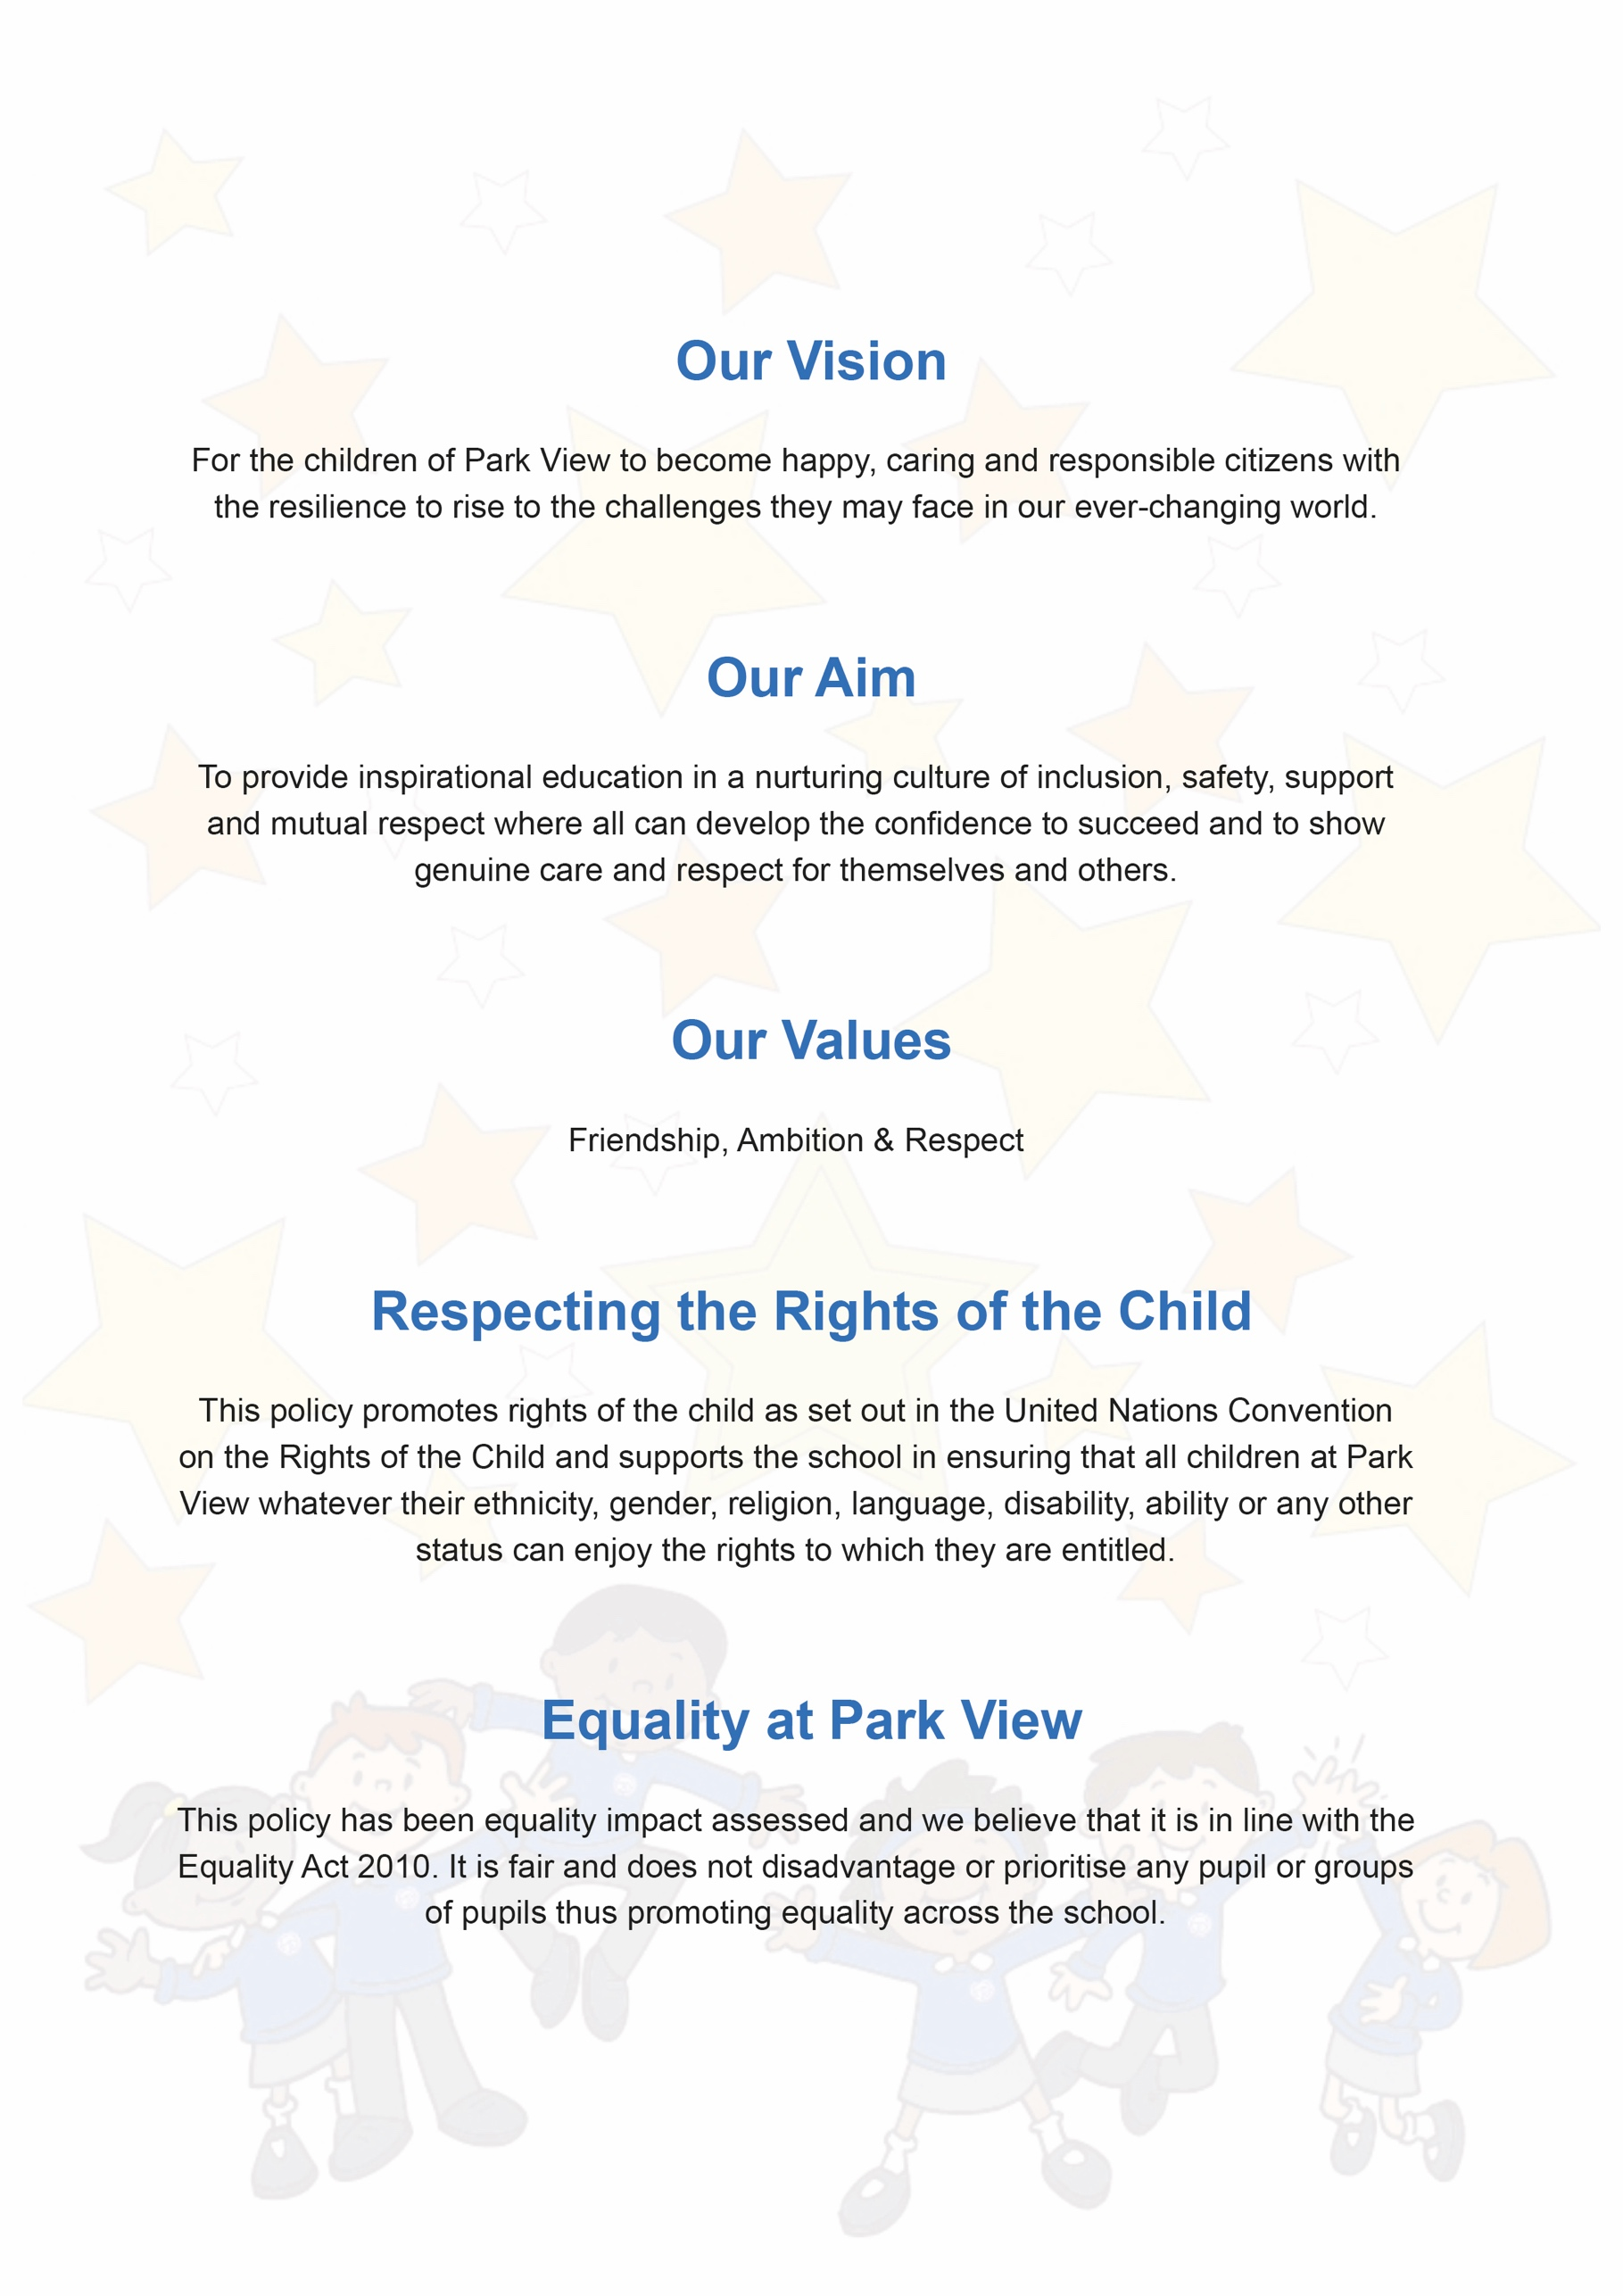

Contents
- Aims | 4
- Legislation and guidance | 4
- Monitoring arrangements | 6
- Links with other policies | 7
Appendix 1: Accessibility audit sample | 8

Document Control
Title
Date
Supersedes
Amendments
Related Policies/Guidance
Review Date

- Aims

Schools are required under the Equality Act 2010 to have an accessibility plan. The purpose of the plan is to:
- Increase the extent to which disabled pupils can participate in the curriculum
- Improve the physical environment of the school to enable disabled pupils to take better advantage of education, benefits, facilities and services provided
- Improve the availability of accessible information to disabled pupils
Our overarching aim is to ensure that pupils with a disability can participate fully in the life of the school, access the curriculum and make good progress from their starting points.
Our school treats all pupils fairly and with respect. This involves providing access and opportunities for all pupils without discrimination of any kind. We aim to make necessary adjustments to the curriculum, the environment and building in order to meet the needs of any child joining our school community.

This policy and plan is available online on the school website, and paper copies and/or enlarged print/braille are available upon request.

Our school is committed to ensuring staff are trained in equality issues with reference to the Equality Act 2010, including understanding disability issues. The school supports any available partnerships to develop and implement the plan.

Our school’s complaints procedure covers the accessibility plan. If you have any concerns relating to accessibility in school, this procedure sets out the process for raising these concerns.

2. Legislation and guidance

This document meets the requirements of schedule 10 of the Equality Act 2010 and the Department for Education (DfE) guidance for schools on the Equality Act 2010. The Equality Act 2010 defines an individual as disabled if he or she has a physical or mental impairment that has a ‘substantial’ and ‘long-term’ adverse effect on his or her ability to undertake normal day to day activities.

Under the Special Educational Needs and Disability (SEND) Code of Practice, ‘longterm’ is defined as ‘a year or more’ and ‘substantial’ is defined as ‘more than minor or trivial’. The definition includes sensory impairments such as those affecting sight or hearing, and long-term health conditions such as asthma, diabetes, epilepsy and cancer.

Schools are required to make ‘reasonable adjustments’ for pupils with disabilities under the Equality Act 2010, to alleviate any substantial disadvantage that a disabled pupil faces in comparison with non-disabled pupils. This can include, for example, the provision of an auxiliary aid or adjustments to premises.

Objectives | Strategies | timescale | staff | Success Criteria
To increase access to the curriculum for pupils with a disability | Differentiated curriculum. Tailored resources to meet the specific needs of the individual. Specific pupil progress tracking.  Targets for pupils with SEND Curriculum reviews.  Consultation with specialist agencies/staff for staff CPD and support.  Employment of specialist staff.  Ensure cover/agency staff have access to pupil SEND information | on-going  10/12/2023 | SENDCO/HT  SENDCO/HT | Pupils with disability access full curriculum and make good progress from their individual starting point  Completed Review of cover/agency staff information – pupil needs being clearly identified and provision outlined
Maintain and improve access to the physical environment | The environment is adapted to the needs of pupils as required. This includes: lift; wheelchair accessible corridors; disabled parking bays; disables toilets and changing facilities  Highly visible markings used to ensure the safety of pupils/students with a visual impairment? | *In place  20/11/2024 or sooner if needed | HT/SMB/ SENDCO  SENDCO/SBM/HT | Pupils with disability can access the building at any starting point during the school year.  *2018 planned school library refurbishment to ensure book-shelves are at wheel chair height. (Has this happened?)  VI service request for environmental audit, complete work during new three year AP cycle.
Improve the delivery of information to pupils  with a disability and their parents/carers | A range of communication methods are in place to ensure information is accessible. This includes: internal signage in braille; induction loops.  Pictorial or symbolic  representations and large print resources supplied as needed  Ensure ‘SEND Information, Advice and Support Service’ (SENDIASS) information is included in SEND Information Report & publish on website  Carry out parent voice/review exercise to ensure accessibility of information via all systems | On-going  12/12/2023  12/12/2023 | SENDCo/ class teachers  SENDCo  SENDCo | Pupils with disability can access information and the curriculum.  Pupils with a disability and their parents/carers can better access information and support  Pupils with a disability and their parents/carers can better access information and support
To strengthen productive working relationships with families of pupils with a disability via strong home school links and multi-agency working | Clear and frequent communication with parents/carers and other professionals to ensure that EHCPs are effective and reviewed regularly | On-going | SENDCo/ Teachers and support  staff | Working practices between school, outside agencies and families effectively support the needs of the children for whom the partnership is in place. This enables the pupil(s) to succeed.

3. Monitoring arrangements

This document will be reviewed every 3 years, but may be reviewed and updated more frequently if necessary. It will be approved by the full governing body.

4. Links with other policies

This accessibility plan is linked to the following policies and documents:
- Risk assessment policy
- Health and safety policy
- Equality information and objectives (public sector equality duty) statement for publication
- Special educational needs (SEND) information report
- Supporting pupils with medical conditions policy

Appendix 1: Accessibility audit

The checklist below is an example of the working document that is used to audit the school’s physical environment. The working document is maintained in school. Below is an example of a review.

Feature: SCHOOL LIBRARY and RECEPTION AREA
Date audited | Details and action for improvement | staff | deadline
Autumn 2016 | Library shelving is not at wheelchair height making it inaccessible for any wheelchair users joining school to access.  Budget set aside for new shelving & furniture and audit/replacement of books. | HT/SMB | Summer 2018

Other features on check-list include:

- classrooms and other learning areas
- corridors
- emergency escape routes
- entrances
- internal signage
- lift
- parking bays
- reception area
- toilets

