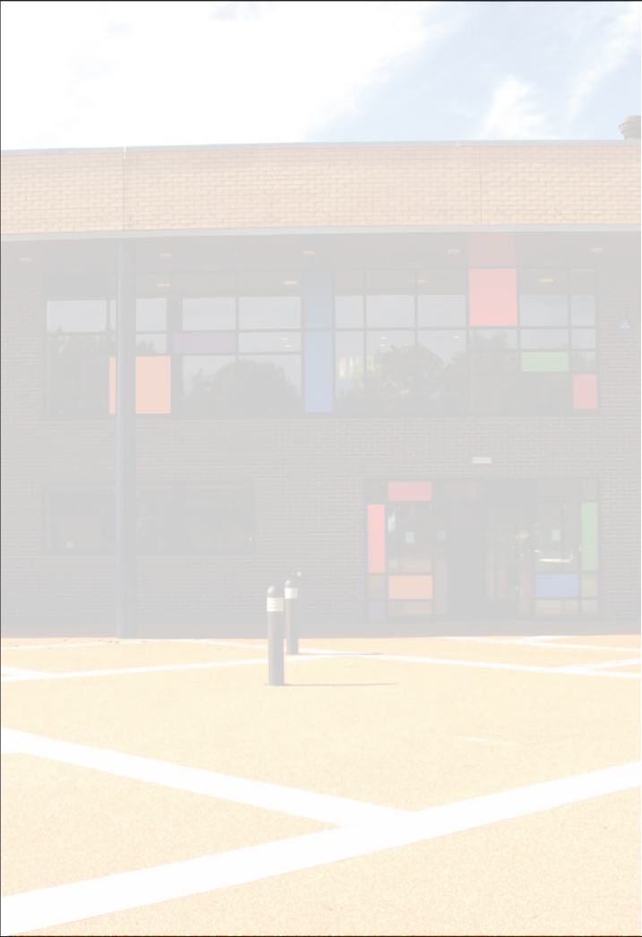

CHARGING AND REMISSIONS
POLICY

November 2022

Definitions
- Charge: a fee payable for specifically defined activities
- Remission: the cancellation of a charge which would normally be payable

Introduction

All education during school hours is free. We do not charge for any activity undertaken as part of the National Curriculum.

Voluntary Contributions

The Governing Body wish to continue to promote and provide a wide range of activities, including visits as part of a broad and balanced curriculum.

When organising school trips or visits or visitors into school to enrich the curriculum and the educational experience of the children, the school invites parents to contribute to the cost. All contributions are voluntary. If we do not receive sufficient voluntary contributions, it may be necessary to cancel the trip. If a trip goes ahead, it may include children whose parents have not paid any contribution. Children cannot be excluded from trips on the basis of financial contribution.

A fundamental principle of charging for school activities is that any charge made cannot exceed the cost of the provision. School cannot subsidise some pupils by "over charging" others.

Activities requiring contributions will be arranged as far in advance as possible so that any payments may be spread over a period of time, or families can make
arrangements to put money aside towards the cost. On most occasions the school makes a financial contribution to the overall cost in order to minimise the cost to parents.

The list below shows examples of the type of activities for which voluntary contributions as asked. This list is not exhaustive:

• visits to museums, farms, galleries etc.
• outdoor adventure activities
• visits to or by a theatre company
• school residential trips
• musical events

School Equipment

• Parents/carers are required to provide suitable clothing for P.E., games and
swimming.
• There will be no charge for the use of any materials, books, instruments or other
equipment for use in connection with education during school hours.
• Parents/carers may be asked to provide their children, voluntarily, with particular
items.
• No child will be disadvantaged by an unwillingness or inability to contribute in this
way.

Education Partly During School Hours

Sometimes an activity may happen partly during and partly outside school hours. If most of the time spent on a non-residential activity occurs during school hours, that activity counts as taking place entirely in school hours and no charge can be made. (Time spent on travel only counts as being during school hours if the travel takes place during school hours.) As an example, a long distance trip might involve much travel before and after normal school hours, but if the time spent at the destination fell mainly within school hours, the trip would count as happening in school time and be free of charge. By contrast, a trip which involved leaving school an hour or so earlier than usual in the afternoon, but then went on until quite late in the evening, would be classified as taking place outside school time. Charges would then be allowed and such activities will be considered as optional extras.

Music Tuition

All children study music as part of the normal school curriculum. We do not charge for this.
There is a charge for individual or small group music tuition, since this is an additional curriculum activity, and not part of the National Curriculum. These individual or small-group lessons are taught by peripatetic music teachers. We make a charge for these lessons but parents in receipt of state benefits are exempt from payment.

Swimming

The school organises swimming lessons for all children in Key Stage 2. These take place in school time and are part of the National Curriculum. We therefore make no charge for this activity. We inform parents when these lessons are to take place.

After School Clubs

Any after school clubs that are run by people other than school staff often require a charge. The cost of such is set by the person or company organising the club.

Damage to School Property

Parents / Carers may be asked to pay for the cost of replacing broken windows, damaged furniture or other equipment and defaced or lost reading / library / text books especially where this occurs as a result of a pupil’s behaviour. Each individual case will be investigated and a request for payment will be made at the discretion of the headteacher.

Residential Visits

If the school organises a residential visit in school time, or mainly in school time, which is to provide education directly related to the National Curriculum, we do not make any charge to cover the costs of board and lodging. In the case of residential visits mainly out of school time, parents will be asked to contribute towards the costs and be involved in fundraising events.

Remissions

On school residential visits for pupils whose parents/carers are receiving income support, income-based job seeker’s allowance, family credit or disability working allowance, board and lodging will not be charged. Charges for other ‘chargeable activities’ may also be fully or partially remitted. Specific details of any remission arrangements will be made clear when parents are informed of charges for individual activities.

This policy on charging pupils and remission was drawn up in accordance with Manchester’s policy and the requirements of Section 110 of the Education Reform Act 1988 and subsequent guidance.

Document Status
Author | School Business Manager
Date of origin | Rev. 11.01.2016
Version | 2
Review requirements | Annually
Date of next review | November 2023
Approval Body | Governing Body
Publication | Website

