Pre-teens (11-13)

Online safety advice
As children between the ages of 11 and 13 make the transition to a more independent stage with the move to secondary school, they become more confident internet users with more varied habits. Internet use can be hugely positive for children, but it’s vital to continue discussing online safety with them.

Have free and frank discussions
Encourage your child to talk to you about how they use the internet and show you what they do. Discuss with them the kinds of things they might come across. A good time to talk is when they get a new device or mention a new website.

Manage their devices
Encourage them to use their tech devices in a communal area such as the living room or kitchen and set up a user account for your child. If you think they aren’t old enough to have a mobile phone or tablet, stay firm and explain the reasons why.

Put yourself in control
Activate parental controls on your home broadband, all devices including mobile phones and games consoles. Safe search settings can also be activated on Google (and other search engines), YouTube and on entertainment sites like iTunes and iPlayer.

Stay safe on the move
Be aware that if your child is accessing the internet using public WiFi they may not have safety features active. Some providers are part of family friendly WiFi schemes with filters to block inappropriate content. Look out for friendly WiFi symbols like Mumsnet Family Friendly WiFi and RDI Friendly WiFi symbols when you’re out and about.

Have an agreement
Agree and set boundaries with them or have a family contract for their internet use, including when and where they can use portable devices and for how long, before they get used to doing their own thing.

Start discussions about social networking early
Talk to children about the benefits and risks of social media before they join any sites. Let them know that anything they upload, email or message could stay around forever online.

Keep private information private
If your child does have a social networking profile, teach them to block or ignore people and how to set strict privacy settings. Request that you or someone you both trust becomes their ‘friend’ or ‘follower’ to check that conversations and posts are appropriate.

Check age ratings
The age ratings that come with games, apps, films and social networks are a good guide to whether they’re suitable for your child. For example, the age limit is 13 for several social networking sites including Facebook and Instagram.

Why it matters: Facts & Stats
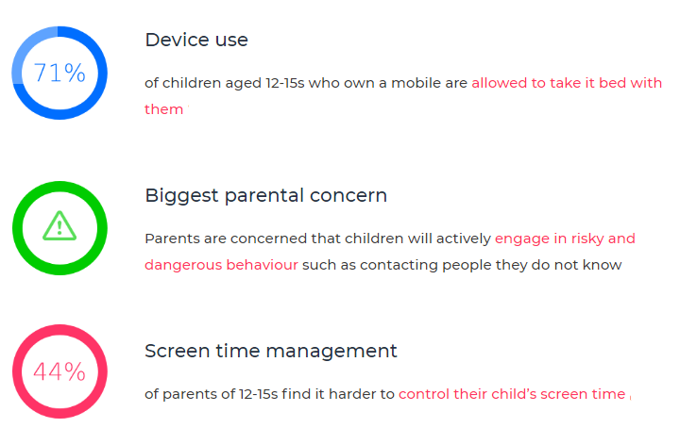

Parent control
Visit: https://www.internetmatters.org/parental-controls/
Many parents can be put off using controls and settings as they think they will be difficult to set up, or complicated to use. Click on the link for step by steps guides, they can help make it simple and straightforward for any device.
You can search parental controls for smartphones and other devices; entertainment & search engines; broadband & mobile networks; social media; and gaming consoles.
Guides to social network, apps and games

Visit: https://www.net-aware.org.uk/

NSPCC NetAware has created simple guides for parents. The guides are for the most popular social networks, apps and games that children are using and what concerns to watch out for.
Age Rating
Age restrictions are put in place to stop those under the required age from being exposed to content which is intended for older users. There are two official ways you can check whether a particular game, app or film is appropriate. The BBFC and PEGI can both be used to check the content is appropriate for the child.
The British Board of Film Classification will inform you of the suitability of films and television. The BBFC can also provide additional warnings regarding the content such as language, adult imagery, violence, threat/horror, dangerous behaviour and anything else that might be deemed inappropriate for the child.
https://bbfc.co.uk/
PEGI (Pan European Games Information) is a content rating system that ensures all video games are labelled with a minimum age recommendation. The ratings are split into age restrictions and content descriptors to help parents understand what the game features.
https://pegi.info/

4 types of Risk
Content risks: The child or young person is exposed to harmful material.
Contact risks: The child or young person participates in adult initiated online activity.
Conduct risks: The child or young person is a perpetrator or victim in peer-to-peer exchange.
Commercial risks: The child or young person is exposed to inappropriate commercial advertising (including extremist content), marketing schemes or hidden costs.
Contact: Who do our children need to be aware of?
- Stranger danger: Not everyone online is who they say they are.
- Cyber-bullying in all forms
- Identity theft (including ‘frape’ (hacking Facebook profiles)) and sharing passwords
Content: What do our children need to be aware of?
-Exposure to inappropriate content.
-Ignoring age ratings in games (exposure to violence, offensive language).
Conduct: What do our children need to be aware of?
-Privacy issues, including disclosure of personal information.
-Digital footprint and online reputation
-Screen time
-Being share aware
Commercial: What do our children need to be aware of?
-Issues of advertisements on body image.
-Gambling
-Extremism and radicalisation
-Spam, pop – ups

Useful sites
www.nspcc.org.uk
www.net-aware.org.uk
www.internetmatters.org/
TALK TO SOMEONE ABOUT ONLINE SAFETY
Whether you want to set up parental controls, adjust privacy settings or get advice on social networks, experts from the free O2 & NSPCC helpline are here to help.
0808 800 5002
BBC Own It (Child friendly guidance)
https://www.bbc.com/ownit
Google: Internet Matters (Includes a game children can play based on e-safety)
https://beinternetawesome.withgoogle.com/en_us/

