SEND INFORMATION REPORT

March 2024

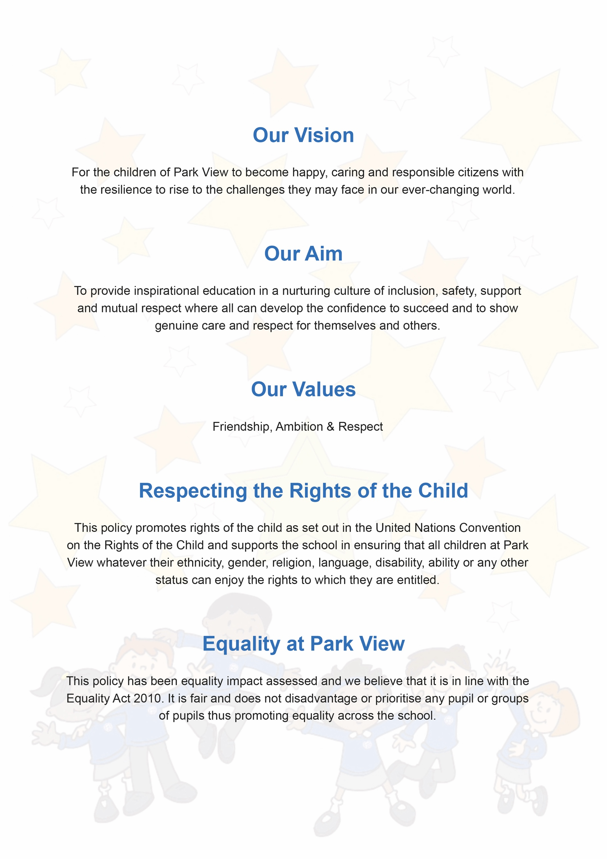

SEND Information Report

Document Control
Title | SEND Information Report
Purpose | To explain the approaches to provision for pupils with SEND
Supersedes
Amendments
Related Policies/Guidance | SEND Policy
Author | Sophie Murfin
Approved Level | Governing Body – Statutory Policy
Date adopted | 25th March 2024
Expires | March 2027
Signature of Chair
Park View Community Primary School
Varley Street
Manchester
M40 7EJ

Park View Community Primary School has a number of policies which are adopted to ensure an equitable and consistent delivery of provision.

Within our policies reference to:
- Governing Body/Governors relate to the members of the Local Governing Body.
- School includes a reference to school or school unless otherwise stated.
- Headteacher includes a reference to Headteacher, Principal or Head of School of a school.

Contents
1. Special Educational Needs and Disability Information Report 4
The kinds of special educational needs and disabilities for which provision is made at Park View Community Primary School 4
Communication and interaction; 4
Cognition and learning; 4
Social, emotional and mental health (SEMH); 4
Our WOW (Wise Owl Well-being) Curriculum focuses on: 4
Sensory and/or physical needs 5

2. Information in relation to the school’s policies for the identification and assessment of pupils with SEND 5

3. Information about the school’s policies for making provision for children with SEND whether or not pupils have an Education, Health and Care Plan 6
How does the school evaluate the effectiveness of its provision? 6
What are the school’s arrangements for assessing and reviewing the progress of pupils with SEND? 6
What is the school’s approach to teaching children with SEND? 6
How does the school adapt the curriculum and the learning environment? 6
What additional support for learning is available for children with SEND? 7
What activities are available to children with SEND beyond the curriculum? 7

4. Arrangements made by the Governing body relating to the treatment of complaints from parents/carers of children with SEND concerning the provision made at the School 7

5. Approach to Transitional Arrangements 8

6. Who can I contact for further information? 8
The contact details of support services for the parents of pupils with SEND 8

Special Educational Needs and Disability Information Report

The SEN Information Report is part of a wider suite of documents relating to SEN, disability and inclusion which can be found here. In particular, it should be read alongside the school’s SEN policy.

The kinds of special educational needs and disabilities for which provision is made at Park View Community Primary School

Park View Community Primary School is a mainstream school which caters for children from 3 – 11 years old. We are inclusive and aim to meet all children’s needs and support their development in the most appropriate way to ensure they reach their full potential. The 0-25 SEND Code of Practice (2015) identifies 'four broad areas of Special Educational Need and support'

Communication and interaction;
We utilise a total communication environment approach – visual timetables, now and next boards, enhanced use of visuals (widgets) to support routine and teaching and learning. We work closely with Speech and Language Therapists to train and coach staff members in supporting children with communication difficulties, and to provide additional assessments and support for children within this area.

Cognition and learning;
We are able to offer a range of intervention work designed to help children achieve their maximum potential e.g., Fast Track and Fresh Start (Read Write Inc), 5 minute box, Toe By Toe, Precision teaching, maths interventions and a variety of other targeted interventions. Training and support is given by Educational Psychology, the SENCo and progress and impact is carefully monitored.

Social, emotional and mental health (SEMH);
We utilise the Boxall Profile to give structured and targeted support to children experiencing SEMH difficulties, and have a number of tailored approaches for children in this area. Interventions alongside the Boxall Profile such as Purrfect Skills and Nurturing Emotional Development are in place from trained staff members.

Our WOW (Wise Owl Well-being) Curriculum focuses on:

- Happy Mind - looking at issues such as mental health, including Mental Health First Aid, self-regulation and mindfulness.
- Healthy Body - looking at nutrition, basic first aid, the changing body, health and prevention, body image and peer pressure, and drugs, smoking and alcohol.
- Hearty Soul - looking at how key skills are incorporated into the curriculum and school life, including resilience, empathy, self-awareness, positivity, excellence, communication, teamwork.

This universal approach is key in underpinning the Social and Emotional wellbeing of our children.
Sensory and/or physical needs.
We work closely with Occupational Therapists to enable us to support sensory and physical needs through a range of activities and interventions, and where necessary, direct work and intervention from the OT. Staff members have received training from OT on specific programmes and approaches, along with the development of structured sensory circuits to support children who have this need identified.

Information in relation to the school’s policies for the identification and assessment of pupils with SEND

The school staff use the graduated response as outlined in “The Code of Practice (2014)”. Pupils who have been identified as potentially having additional needs are monitored using Cause for Concern forms, which forms part of the cycles of Assess, Plan, Do, Review. This process is further supported with the following approaches-

- First and foremost, High Quality Teaching approaches in the classroom underpinned by adaptive teaching and scaffolding and informed by the Inclusion Toolkit.
- Further diagnostic testing directed by the SENCO.
- Observations by staff
- Additional intervention as identified within Assess, Plan, Do, Review to provide support “additional to and different from” peers.
- Following this process, or in cases where significant need presents immediately. The SENCO may then ask for additional diagnostic assessment to be undertaken by other professionals e.g. Educational Psychologists, CAMHS, Speech and Language Therapy, School Health Nurse, Outreach Support.

Learning is regularly monitored and assessed by teachers and discussed termly with SLT (the Senior Leadership Team). When a child is causing concern the class teacher collects evidence such as work samples, progress and assessment data or a behaviour log, where applicable and enters the cycle of “assess, plan, do, review”, as detailed above.

The school’s designated SENCO is Mrs Janine Lewis, who can be contacted via the office or by phoning 0161 519 8562

Information about the school’s policies for making provision for children with SEND whether or not pupils have an Education, Health and Care Plan.

How does the school evaluate the effectiveness of its provision?

The SENCO monitors the progress of children with SEND closely by classroom observation, data and consultation with parents/carers and teachers.

The SENCO conducts an annual review for all children who have an EHC Plan and ensures that a provision map is in place and followed by all staff working with the child. Regular meetings are held with specialists/professionals to ensure the support is appropriate to the child’s needs.
Formal SEN support plan reviews are held termly with the parent/carer, teacher, child (if appropriate) and in some cases with the SENCO or other agencies supporting the child.

Senior leaders carry out Learning Walks, observations of lessons and interventions and scrutinise books regularly, in line with the Monitoring and Evaluation schedule.

What are the school’s arrangements for assessing and reviewing the progress of pupils with SEND?

Class teachers review progress against the EYFS Profile / Development Matters, Age Related Expectations, Pre Key Stage Standards, The Engagement Scale and against targets within SEND Support Plans.

The SENCO monitors progress on a termly basis at least.

Senior Leaders hold termly pupil progress meetings with teachers, to discuss progress.

What is the school’s approach to teaching children with SEND?

Children with SEND have access to a broad and balanced curriculum and all extra-curricular activities in line with our inclusive ethos.

Teaching and lessons are adapted to match the particular needs of the child in terms of activities, resources, teaching approaches and expectations. A range of techniques are used to scaffold learning and ongoing professional development to promote high quality teaching and adaptions is in place through the school CPD offer. Effort as well as achievement is recognised in all areas of the curriculum.

How does the school adapt the curriculum and the learning environment?

Teachers plan lessons that will engage all children and whilst support is forthcoming, we aim to make our children independent learners. Scaffolding learning is encouraged, with the use of (for example)

- Task plan
- Chunked learning
- Pre-teaching of vocabulary and concepts
- Use of manipulatives and concrete resources
- Word banks
- Writing frames
- Access to technology to support learning

The school is well resourced and provides a stimulating environment.

The school liaises closely with a number of specialists to work with individual children on particular aspects of development/learning, as detailed above in part 1.

What additional support for learning is available for children with SEND?

Additional support is also sought from agencies which include:
- Educational Psychologist
- Speech and Language Therapy
- Visual Impaired team
- Hearing impaired team
- School Health Services
- GP
- Information, Advice and Support (IAS) Service (formerly Parent Partnership Service)
- CAMHS (Child & Adolescent Mental Health Service)
- Advice from staff within other schools who have more expertise and knowledge.

Teaching assistants provide individual and small group support in the classroom and additional support during interventions, working with children on phonics, reading, writing, fine motor skills, speech and language and specific literacy and numeracy difficulties.

What activities are available to children with SEND beyond the curriculum?

All children have access to our clubs which provide a range of learning activities and a wide range of curriculum clubs, such as languages, sports, music and arts and crafts. We encourage children with SEN/D to take part in all extra-curricular.

The Designated Safeguarding Lead is the Headteacher, Sarah Navin. She is supported by a team who are all specifically trained in this role also, with the DSL, Tom Silver and Deputy DSL’s Katy Mehaffy, Rachel Brotherton and Amanda Dale.

Arrangements made by the Governing body relating to the treatment of complaints from parents/carers of children with SEND concerning the provision made at the school

If parents/carers of children with SEND have concerns they should share these initially with the class teacher or the SENCO. We will always listen to parental / carer concerns and try our best to find an acceptable solution or way forward. If parents/carers are not satisfied, they are welcome to make an appointment to meet with the Headteacher, J. Brownlee, to discuss the issues further.

If you are still not happy with how your concerns have been dealt with, you should then write a formal letter to the Chair of Governors. The Governing Body will then deal with these concerns following the procedures of the school complaint’s policy.

If parents/carers are not happy with the outcome, they can then take their concern to the Local Authority Complaints Officer.

Approach to Transitional Arrangements
When a child starts at our school, contact is made with their previous school, nursery or other Early Years provider, to ensure a smooth transition and that all SEND information in terms of reports, plans, documentation etc is shared. Consent is always sought from parents/carers prior to this and records are stored securely but shared with all relevant staff. When children leave our school, we ensure all SEND records are passed on to the SENCO at the receiving school. Meetings are also held and visits organised, to ensure a smooth transition and that there is continuity in the provision, adaptations, scaffolding techniques and support provided.

Who can I contact for further information?
If you have further questions or concerns regarding SEND matters, please do not hesitate to contact us.

Park View Community Primary School
Varley Street
Manchester
M40 7EJ
0161 519 8562

The contact details of support services for the parents of pupils with SEND.

For free confidential and impartial information, advice and support about any matters relating to Special Educational Needs and Disabilities of children and young people up to the age of 25 years.

SENDIASS - Information, Advice and Support (IAS) Manchester

https://www.iasmanchester.org/
email: parents@manchester.gov.uk or info@iasmanchester.org

Telephone: 0161 209 8356

SENDIASS, Hulme District Office,323 Stretford Road, Hulme, Manchester, M15 4UW.

EHCP Team
Telephone: 0161 245 7439 Email: sen@manchester.gov.uk

Education Health and Care Team, Children and Families Directorate PO Box 532, Town Hall, Manchester, M60 2LA.

Enquiries about requests for Education, Health and Care Plans and Statutory Assessments

Travel Co-ordination Unit
Telephone: 0161 219 6400 Email: hometoschool@manchester.gov.uk

Enquiries about home to school transport for children with statements of SEN or EHC plans. Please note that telephone enquiries are answered by Environment On Call.

Specialist Resource Teams
Telephone: 0161 245 7180 Email: shortbreaks@manchester.gov.uk

Enquiries about short breaks for children and young people with SEND.

- Contact details of support services for supporting pupils with SEND in transferring between phases of education.

Information, Advice and Support (IAS) Manchester
Telephone: 0161 209 8356 Email: parents@manchester.gov.uk
For free confidential and impartial information, advice and support about any matters relating to Special Educational Needs and Disabilities of children and young people up to the age of 25 years.

Statutory Assessment Team
Telephone: 0161 245 7445 Email: sen@manchester.gov.uk
Advice on how to support your child with transition to high school and further education

- Information on where the local authority’s local offer is published

http://manchester.fsd.org.uk/kb5/manchester/fsd/category.page?newcategory=3

https://search3.openobjects.com/mediamanager/manchester/fsd/files/manchester_city_council_m ail_-_the_send_local_offer_website_has_been_upgraded_-_children_and_families_broadcast.pdf

For information about Manchester‘s Special Educational Needs and Disabilities (SEND) Local Offer visit www.manchester.gov.uk/sendlocaloffer . Here you will find out more about:
- Education and work
- Health
- Independent Living
- Law and your rights
- Money
- Places to Go
- Travel and Transport
- Where to Get Help
- Parent Support Groups
- Short Breaks
- Things to do

