EQUALITY POLICY

March 2024

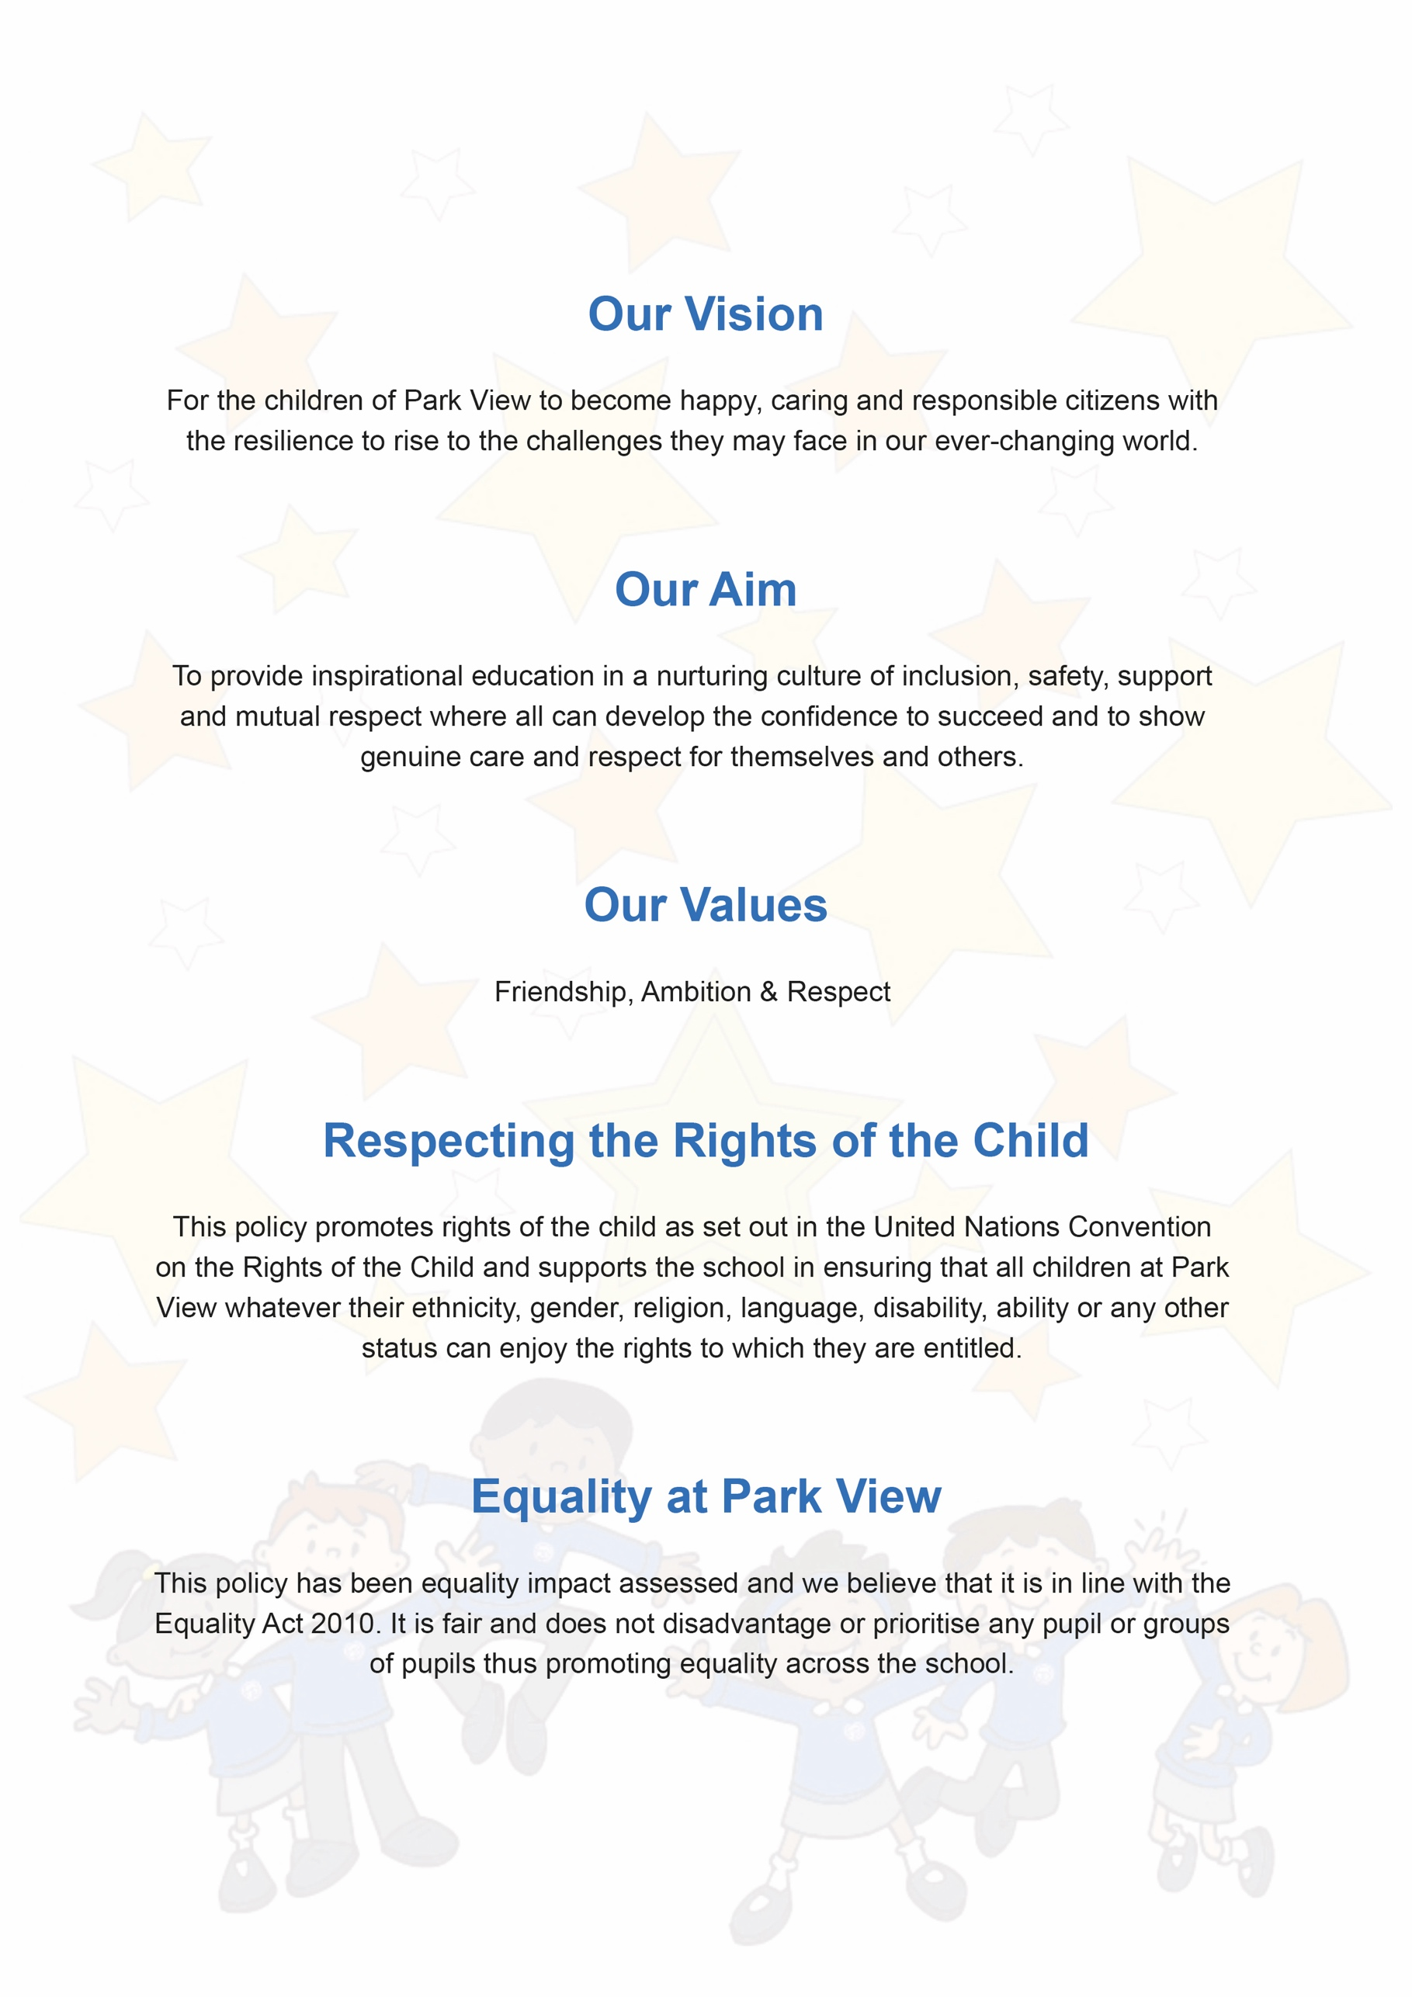

Equality Policy
Document Control
Title | Equality and Diversity
Purpose | We aim to create a working environment in which all individuals are able to make best use of their skills, free from discrimination or harassment, and in which all decisions are based on merit.
Supersedes | Previous version
Amendments | Replaces previous Equality Policy
Related Policies/Guidance | Recruitment and Selection Policy
Author | Sophie Murfin
Approved Level | Governing Body – Statutory Policy
Date adopted | 25th March 2024
Expires on | March 2025
Signature of Chair
Park View Community Primary School
Varley Street
Manchester
M40 7EJ

Park View Community Primary School has a number of policies which are adopted to ensure an equitable and consistent delivery of provision.

Within our policies reference to:
- Governing Body/Governors relate to the members of the Local Governing Body.
- School includes a reference to school or school unless otherwise stated.
- Headteacher includes a reference to Headteacher, Principal or Head of School of a school.

Contents

1. Introduction 4
2. Scope and purpose 5
3. Roles and responsibilities 5
4. Forms of discrimination 5
5. Applying our policy to recruitment and selection 6
6. Applying our policy to training, promotion, pay decisions and conditions of service 7
7. Applying our policy when terminating employment 8
8. Disability discrimination 8
9. Breaches of this policy 8
10. Review of policy 9

- Introduction

Park View Community Primary School is committed to providing high quality teaching and learning for our pupils. We recognise that by valuing and promoting equal opportunities in employment for all employees and job applicants, and avoiding unlawful discrimination in employment and delivery of services, we will be able to deliver first class education and value the differences workforce brings to the Trust.

We aim to create a working environment in which all individuals are able to make best use of their skills, free from discrimination or harassment, and in which all decisions are based on merit. We also value diversity and recognise the varied contributions that a diverse workforce brings to an organisation; we are committed to drawing on different perspectives and experiences of individuals which will add value to what we do.

We will ensure that we do not discriminate against staff on the basis of age, disability, gender reassignment, gender definition, intersex and non-binary, marital or civil partner status, pregnancy or maternity, race, colour, nationality, ethnic or national origin religion or belief, sex or sexual orientation (the protected characteristics).

The principles of non-discrimination also apply to how we expect our staff to treat colleagues, pupils, parents and carers, visitors, clients, customers, suppliers and former staff regardless of whether the legal protection of having a protected characteristic applies.

This policy complies with the requirements of the Gender Reassignment Act 2004 and the Equality Act 2010. Under the general public sector equality duty of the Equality Act 2010, our Trust must have due regard to and are committed to:

- eliminate discrimination, harassment and victimisation;
- advance equality of opportunity between people who share a protected characteristic and those who do not; and
- set diversity objectives
- identify a senior level champion for leading the diversity strategy
- secure top-level ownership and sponsorship
- develop and cascade a diversity vision statement
- foster good relations between people who share a protected characteristic and those who do not.

The duty covers the protected characteristics of race, disability, sex, age, sexual orientation, religion or belief, pregnancy and maternity, gender reassignment, gender definition, intersex and non-binary. The first part of the duty - the duty to eliminate discrimination, harassment and victimisation - also applies to the protected characteristic of marriage and civil partnership. As part of our duty we publish on our website, information relating to any persons who share a relevant protected characteristic who are affected by our policies and practices. We will also publish gender pay gap reporting in line with the regulations, once the Trust employs over 250 employees.

As part of the application of this policy, the School may collect, process and store personal data and special categories of data in accordance with our data protection policy. We will comply with the requirements of Data Protection Legislation (being the UK General Data Protection Regulation and Data Protection Act 2018) and any implementing laws, regulations and secondary legislation, as amended or updated from time to time, in relation to how we collect, hold and share personal data.

This policy has been implemented following consultation with Trade Union representatives. It has been formally adopted by the School.

This policy does not form part of any employee's contract of employment and may be amended at any time.

- Scope and purpose

This policy covers all individuals working at all levels and grades in the School; governors, executive team, Head of School, senior leadership, employees, consultants, contractors, trainees, part-time and fixed-term employees, volunteers, casual workers and agency staff (collectively referred to as employees in this policy).

This policy applies to all aspects of the employment relationship and covers job advertisements, recruitment and selection, training and development, opportunities for promotion, appraisals, conditions of service, pay and benefits, conduct at work, disciplinary and grievance procedures, and termination of employment. It also applies to former employees for example in the provision of employment references. This policy focuses on employment and does not cover the provision of services to our pupils.

The purpose of this policy is to set out our approach to equal opportunities, how we will tackle discrimination and how we will put our commitment into action and comply with the law, to ensure that equality and diversity is promoted in the workplace and our employees are not subject to and do not commit unlawful acts of discrimination.

- Roles and responsibilities

Our Board has overall responsibility for the effective operation of this policy and for ensuring compliance with equality legislation. Day-to-day operational responsibility for this policy including regular review of this policy, has been delegated to the Head of School/Principal.

All senior leaders must set an appropriate standard of behaviour, lead by example and ensure that those they manage adhere to the policy and promote our aims and objectives with regard to equal opportunities. Senior leaders will be given appropriate training on equal opportunities awareness, and recruitment and selection best practice.

All employees must be aware of this policy and have a duty to act in accordance with this policy and not to discriminate against or harass other people including employees, former employees and job applicants treating them with dignity at all times. This also applies on work-related trips or events including social events. They should also apply this to how they treat members of the public in the provision of services and should support the Trust in meeting its commitment to provide equal opportunities for all and promoting diversity in the workplace.

If you are involved in management or recruitment, or if you have any questions about the content or application of this policy, you should contact your Principal/Head of School to request training or further information.

Staff are invited to comment on this policy and suggest ways in which it might be improved by contacting their Principal/Head of School.

- Forms of discrimination

Discrimination by or against an employee is generally prohibited unless there is a specific legal exemption. Discrimination may be direct or indirect and it may occur intentionally or unintentionally.

Direct discrimination occurs where someone is treated less favourably because of one or more of the protected characteristics as set out above. For example, rejecting a job applicant because of their religious views or because they might be gay. In limited circumstances, employers can directly discriminate against an individual for a reason related to any of the protected characteristics where there is an occupational requirement. The occupational requirement must be crucial to the post and a proportionate means of achieving a legitimate aim. It will only be exceptional circumstances that this will apply in our Trust.

Indirect discrimination occurs where someone is disadvantaged by a provision, criterion or practice that applies to everyone but puts people with a protected characteristic at a particular disadvantage. Such a requirement will need to be objectively justified. For example, requiring a job to be done full-time rather than part-time would adversely affect women because they generally have greater childcare commitments than men. Such a requirement would be discriminatory unless it can be objectively justified.

Harassment related to any of the protected characteristics is prohibited. Harassment is unwanted conduct that has the purpose or effect of violating someone's dignity, or creating an intimidating, hostile, degrading, humiliating or offensive environment for them. Pregnancy and maternity, and marriage and civil partnership are not protected directly under the harassment provisions. However, pregnancy and maternity harassment would amount to harassment related to sex, and harassment related to civil partnership would amount to harassment related to sexual orientation. Harassment is dealt with further in our Anti-Bullying and Harassment Policy.

Victimisation is also prohibited. This is less favourable treatment of someone who has complained or given information about discrimination or harassment, or supported someone else's complaint.

Discrimination by association is where an individual is directly discriminated against or harassed for association with another individual who has a protected characteristic.

Discrimination by perception is where an individual is directly discriminated against or harassed based on a perception that a person has a particular protected characteristic irrespective of whether they do have that protected characteristic (this does not include marriage and civil partnership and pregnancy and maternity).

Third-party harassment occurs where an employee is harassed and the harassment is related to a protected characteristic (other than marriage and civil partnership, and pregnancy and maternity), by third parties such as parents and carers, clients or customers.

Part-time and fixed-term staff should be treated the same as comparable full-time or permanent staff and enjoy no less favourable terms and conditions (on a pro-rata basis where appropriate) unless different treatment is justified.

- Applying our policy to recruitment and selection

We aim to ensure that no job applicant suffers discrimination because of any of the protected characteristics. Our recruitment procedures are reviewed regularly to ensure that individuals are treated on the basis of their relevant skills and abilities. All applicants will be provided with a copy of our Recruitment Privacy Notice which sets out how we will gather, process and hold personal data of individuals during the recruitment process. Our recruitment processes are set out in our Recruitment and Selection Policy.

Job selection criteria as set out in the person specification will be regularly reviewed to ensure that they are relevant to the job. Short listing of applicants should be done by more than one person wherever possible and will be carried out objectively against the requirements of the job.

Job advertisements should avoid stereotyping or using wording that may discourage groups with a particular protected characteristic from applying.

We will take reasonable steps, where appropriate depending on the situation, to ensure that our vacancies are advertised to a diverse labour market. This policy will be made available to applicants upon request.

Applicants will not be asked about health or disability before a job offer is made, other than where it is necessary to;

- establish if an applicant can perform an intrinsic part of the job (subject to any reasonable adjustments).
- establish if any reasonable adjustments need to be made to enable an applicant to have a fair interview or assessment.
- carry out equal opportunities monitoring (which will not form part of the decision-making process).

Job offers will be conditional upon a satisfactory medical check in accordance with our obligation under Keeping Children Safe in Education, where a school must verify the candidate’s mental and physical fitness to carry out their work responsibilities in accordance with the Education (Health Standards) (England) Regulations 2003.

Applicants will not be asked about past or current pregnancy or future intentions related to pregnancy or gender identity or history. Applicants will not be asked about matters which may suggest an intention to discriminate on ground of a protected characteristic. Applicants will be asked to clarify which pronoun they would prefer to be referred to.

We are required by law to ensure that all employees are entitled to work in the UK. Assumptions about immigration status should not be made based on appearance, name or apparent nationality. All prospective employees, regardless of nationality, must be able to produce original specified documents before employment starts to satisfy current immigration legislation. The list of acceptable documents is available from Human Resources.

To ensure that this policy is operating effectively, and to identify groups that may be underrepresented or disadvantaged in our School, we monitor diversity data as part of the recruitment process and as set out in our Recruitment Privacy Notice and Data Protection Policy. Provision of this information is voluntary and it will not adversely affect an individual's success at recruitment or any other decision related to their employment. The information is removed from applications before short listing, and kept in an anonymised format solely for the purposes stated in this policy. Analysing this data helps us take appropriate steps to avoid discrimination and improve equality and diversity.

- Applying our policy to training, promotion, pay decisions and conditions of service

All employees will be provided with a copy of our Workforce Privacy Notice which sets out how we will collect, hold and share personal data of individuals during their employment.

Employees training needs will be identified through the appraisal process. All employees will be given appropriate access to training for their job and in order to enable them to progress within the School.

Pay and promotion decisions will be based on an employee’s performance (where relevant), skills and experience and as detailed in our Pay Policy.

Our benefits and facilities are reviewed regularly to ensure that they are available to all employees who should have access to them and that there are no unlawful obstacles to accessing them.

Relevant national and local conditions of service within our School as applied to our employees, will meet the requirements of equal opportunities.

- Applying our policy when terminating employment

We will ensure that redundancy criteria and procedures are fair and objective and are not directly or indirectly discriminatory.

We will also ensure that disciplinary procedures and penalties are applied without discrimination, whether they result in disciplinary warnings, dismissal or other disciplinary action.

- Disability discrimination

Disability discrimination includes direct or indirect discrimination, any unjustified less favourable treatment because of the effects of a disability, and failure to make reasonable adjustments to alleviate the effects caused by a disability.

If you are disabled or become disabled, we encourage you to tell us about your condition so that we can support you as appropriate.

If you experience difficulties at work because of your disability, you may wish to contact your line manager to discuss any reasonable adjustments that would help overcome or minimise the difficulty. Your line manager may wish to consult with you and your medical adviser(s) about possible adjustments. We will consider the matter carefully and try to accommodate your needs within reason. If we consider a particular adjustment would not be reasonable, we will explain our reasons and try to find an alternative solution where possible.

We will monitor the physical features of our premises to consider whether they place disabled employees or job applicants at a substantial disadvantage compared to other employees. Where reasonable, we will take steps to improve access for employees who have a disability.

As a Disability Confident Committed employer, we are committed to inclusivity and accessibility. We guarantee to interview a disabled applicant, provided they meet the minimum criteria for the job. This applies to all internal and external vacancies.

- Breaches of this policy

If you believe that you may have been discriminated against you are encouraged to raise the matter through our Grievance Procedure. If you believe that you may have been subject to harassment you are encouraged to raise the matter through our Anti- Bullying and Harassment Policy. If you are uncertain which policy applies or need advice on how to proceed you should speak to your line manager.

Allegations regarding potential breaches of this policy will be treated in confidence and investigated in accordance with the relevant procedure. Employees who make such allegations in good faith will not be victimised or treated less favourably as a result. False allegations which are found to have been made in bad faith will, however, be dealt with under our Disciplinary Procedure.

Any member of staff who is found to have committed an act of discrimination or harassment will be subject to disciplinary action. Such behaviour may constitute gross misconduct and, as such, may result in summary dismissal. We take a strict approach to serious breaches of this policy.

- Review of policy

This policy is reviewed every three years by School in consultation with union representatives. We will monitor the application and outcomes of this policy to ensure it is working effectively.

Section 60 of the Equality Act 2010
Keeping Children Safe in Education 2023

