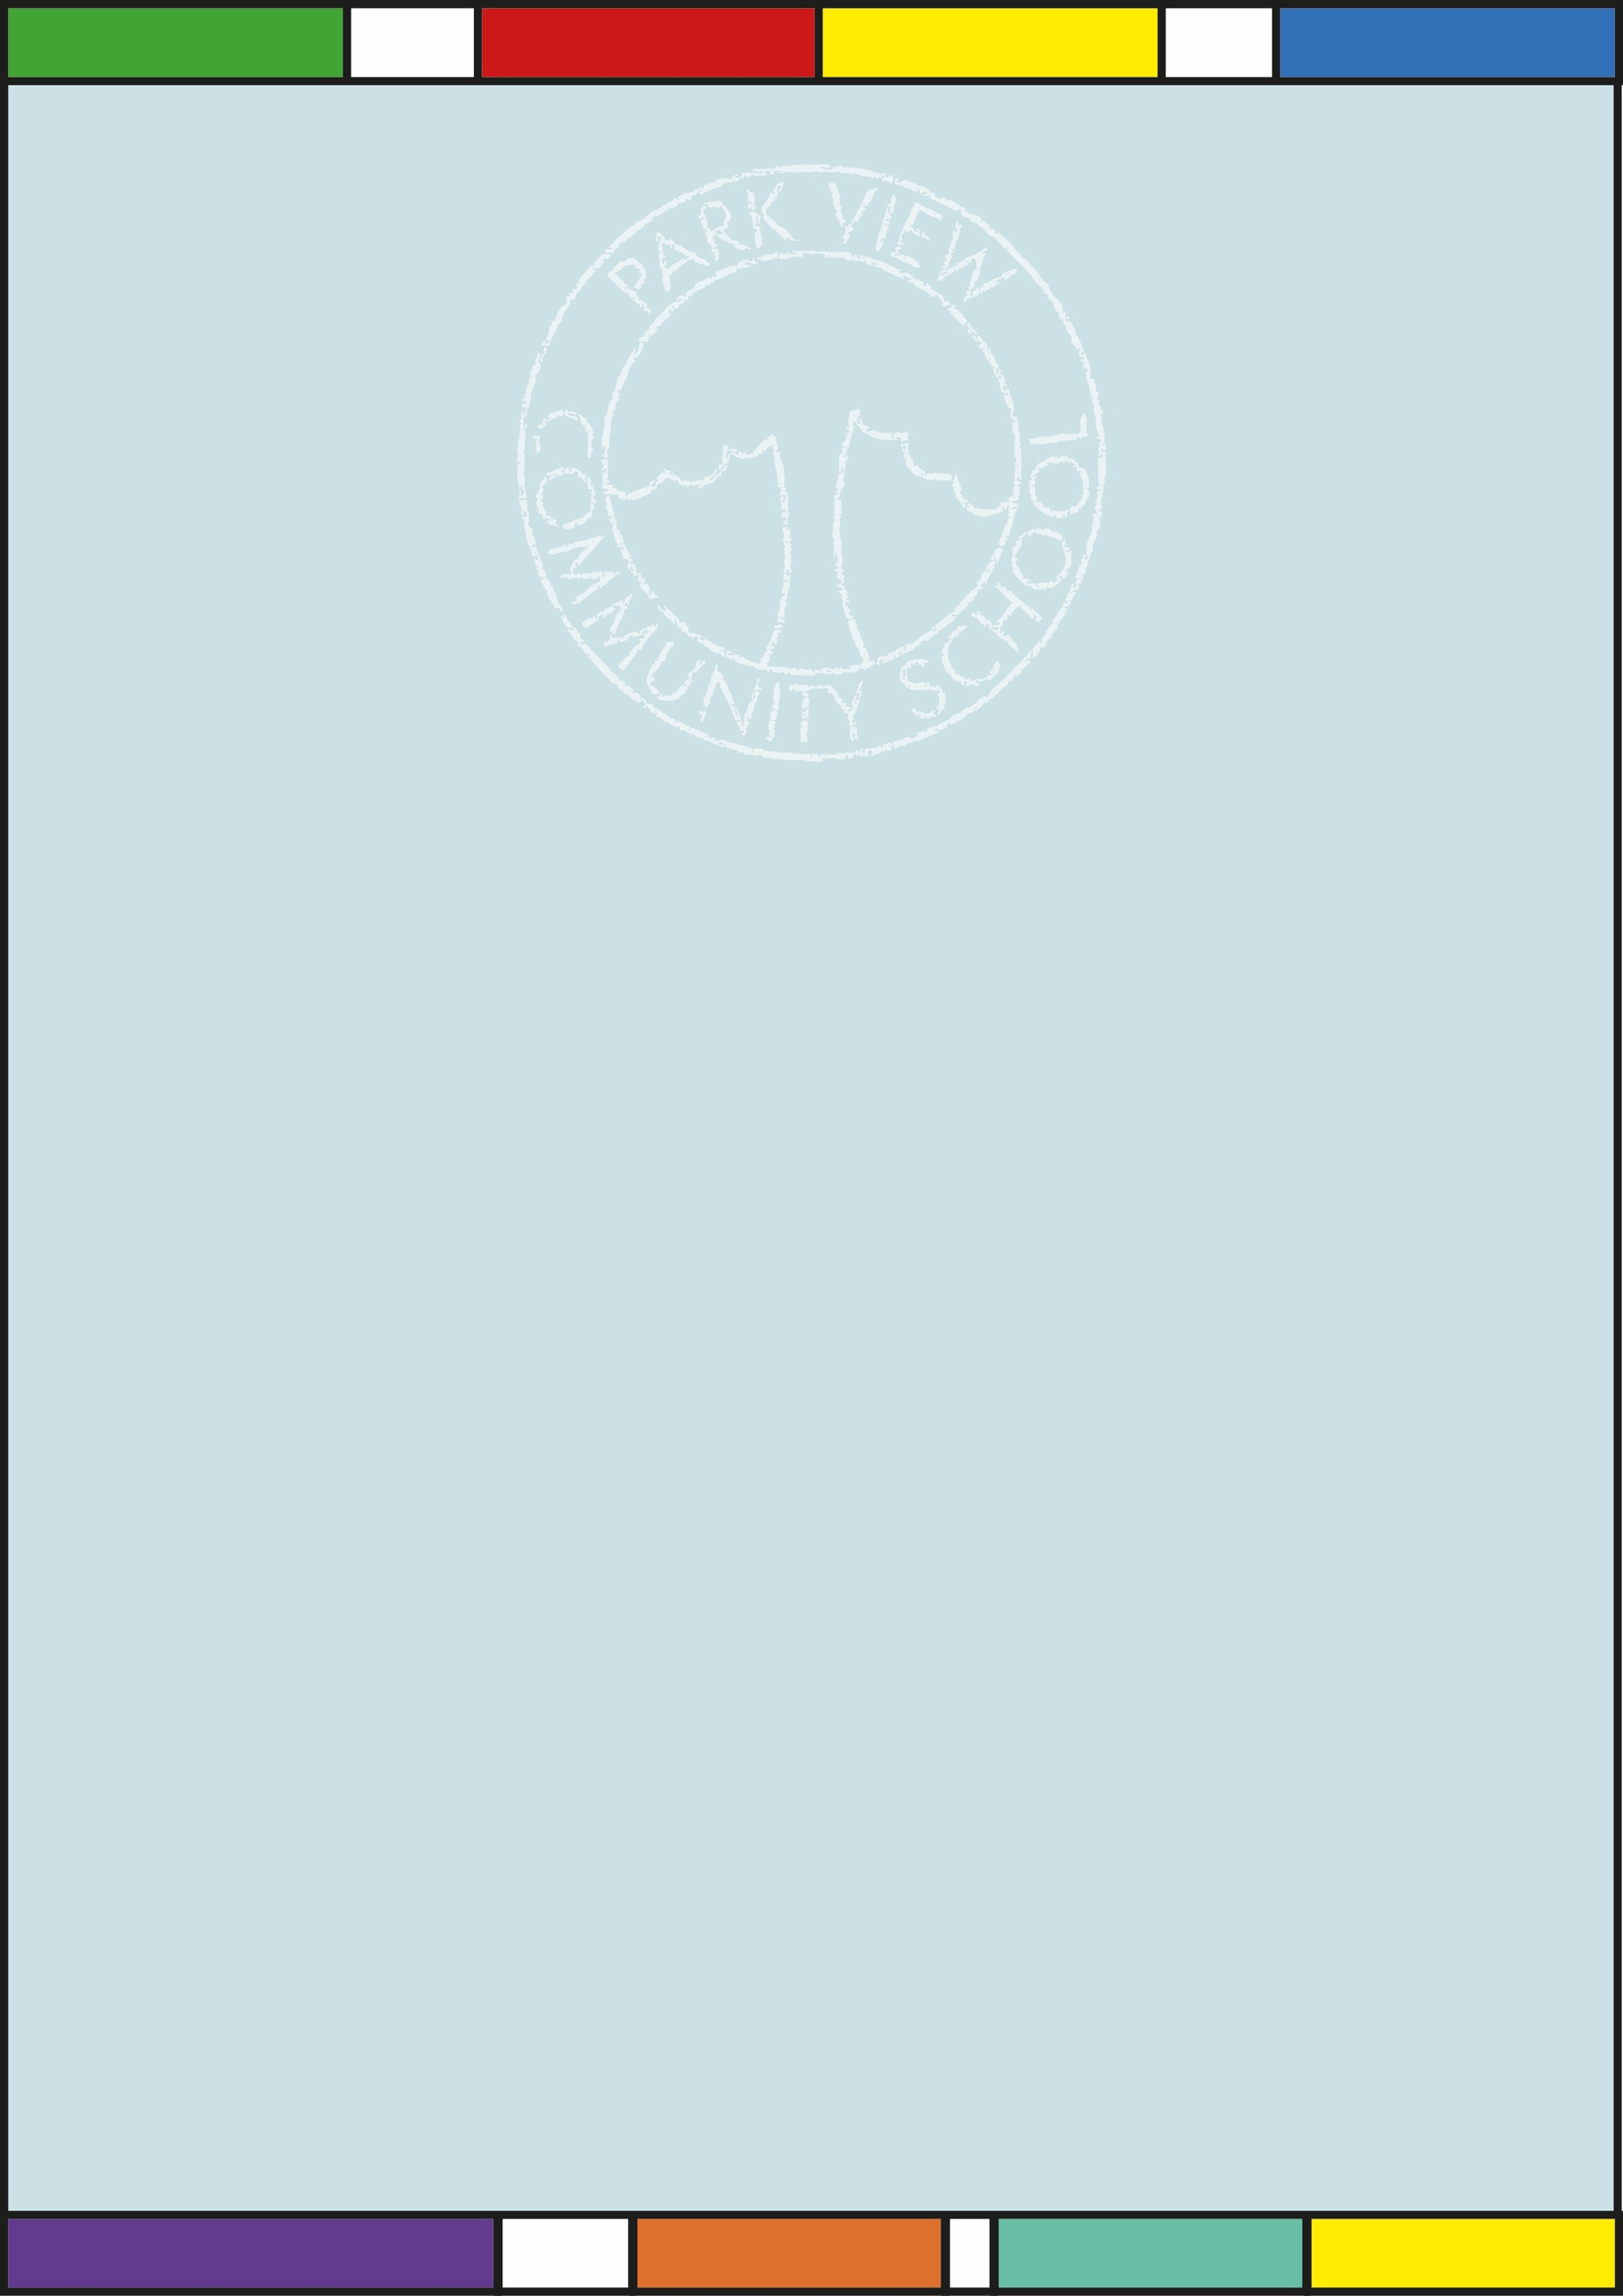

SEND Provision - Intent, Implementation and Impact

February 2024

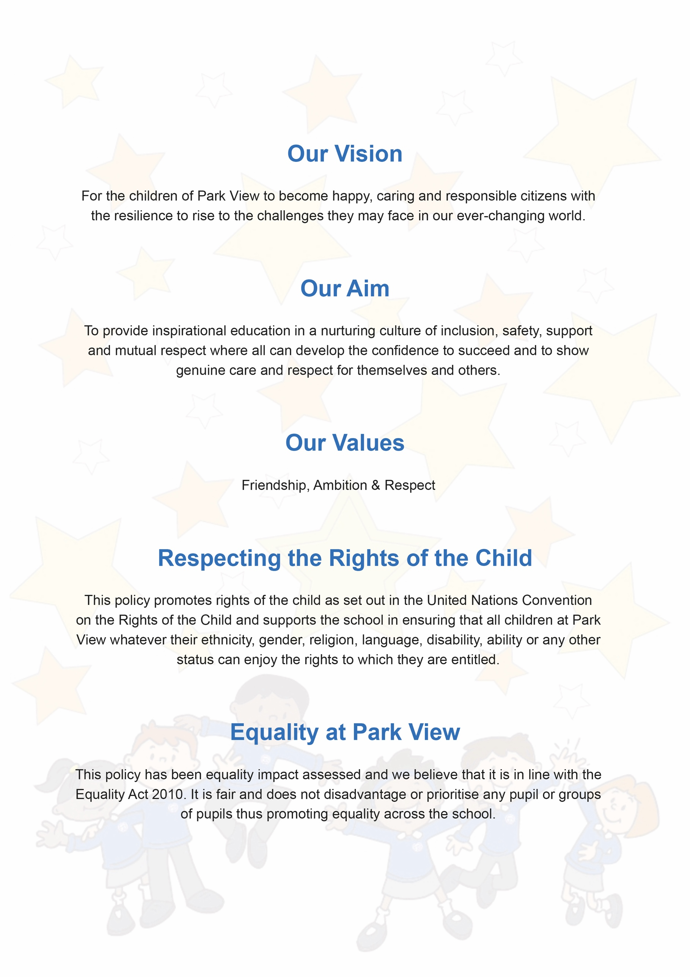

SEND Provision - Intent, Implementation and Impact
Intent | Implementation | Impact
At Park View Community School, our intention for Special Educational Needs and/or Disabilities (SEND) is to ensure that all Pupils receive a high-quality and ambitious education regardless of need or disability. We believe that it is vital that our pupils are equipped with the tools needed to become independent, confident learners both in and out of the classroom.  Through our high-quality planning, teaching and provision we:  Strive for early identification and intervention for SEND to ensure that progress and opportunities are maximised  Ensure that all Pupils have access to a broad and balanced curriculum which is differentiated to enable Pupils to fulfil their potential  Provide an accessible learning environment which is tailored to the individual needs of all pupils  Develop Pupils’ independence  Regularly monitor the progress of Pupils with SEND, using a child-centred approach  Provide good quality and relevant training for all staff members supporting Pupils with SEND  Work in partnership with parents and carers  Work closely with external agencies and other professionals to hone and develop our provision for Pupils with SEND. | At Park View Community School, every teacher is a teacher of SEND. As such, inclusion is a thread that runs through every area of the school enhanced by collaboration between senior leaders, teachers, support staff, external agencies, parents and most importantly, the child.  At Park View Community School, pupils with SEND will:  Be included in all aspects of the school day  Be provided with high quality teaching, differentiated to their needs  Be respected and their contributions valued and acknowledged  At Park View Community School, pupils with SEND may:  Have specific 1:1 or small group intervention to support their Phonics, Maths or other learning  Take part in social and emotional support interventions such as Lego Therapy, The Anxiety Gremlin and 60 mindful minutes  Have additional support from our Speech and Language Therapy Teaching assistant  Work alongside external agencies such as an Educational Psychologist, Speech and Language Therapist, Occupational Therapist and the Information, Advice and Support Service for Manchester. | As a result:  Pupils at Park View Community School feel happy, safe and respected  Behaviour in school is good and diversity is celebrated  Pupils demonstrate high levels of engagement in activities, developing their independent learning and social skills  Pupils with SEND have made good progress in RWI and WellComm (Speech and Language) from their starting points due to the use of resources and small group intervention which meets the needs of the pupils  On leaving Park View Community School, Pupils with SEND have developed good independence skills.

