Relationships & Sex Education (RSE) Policy

March 2023

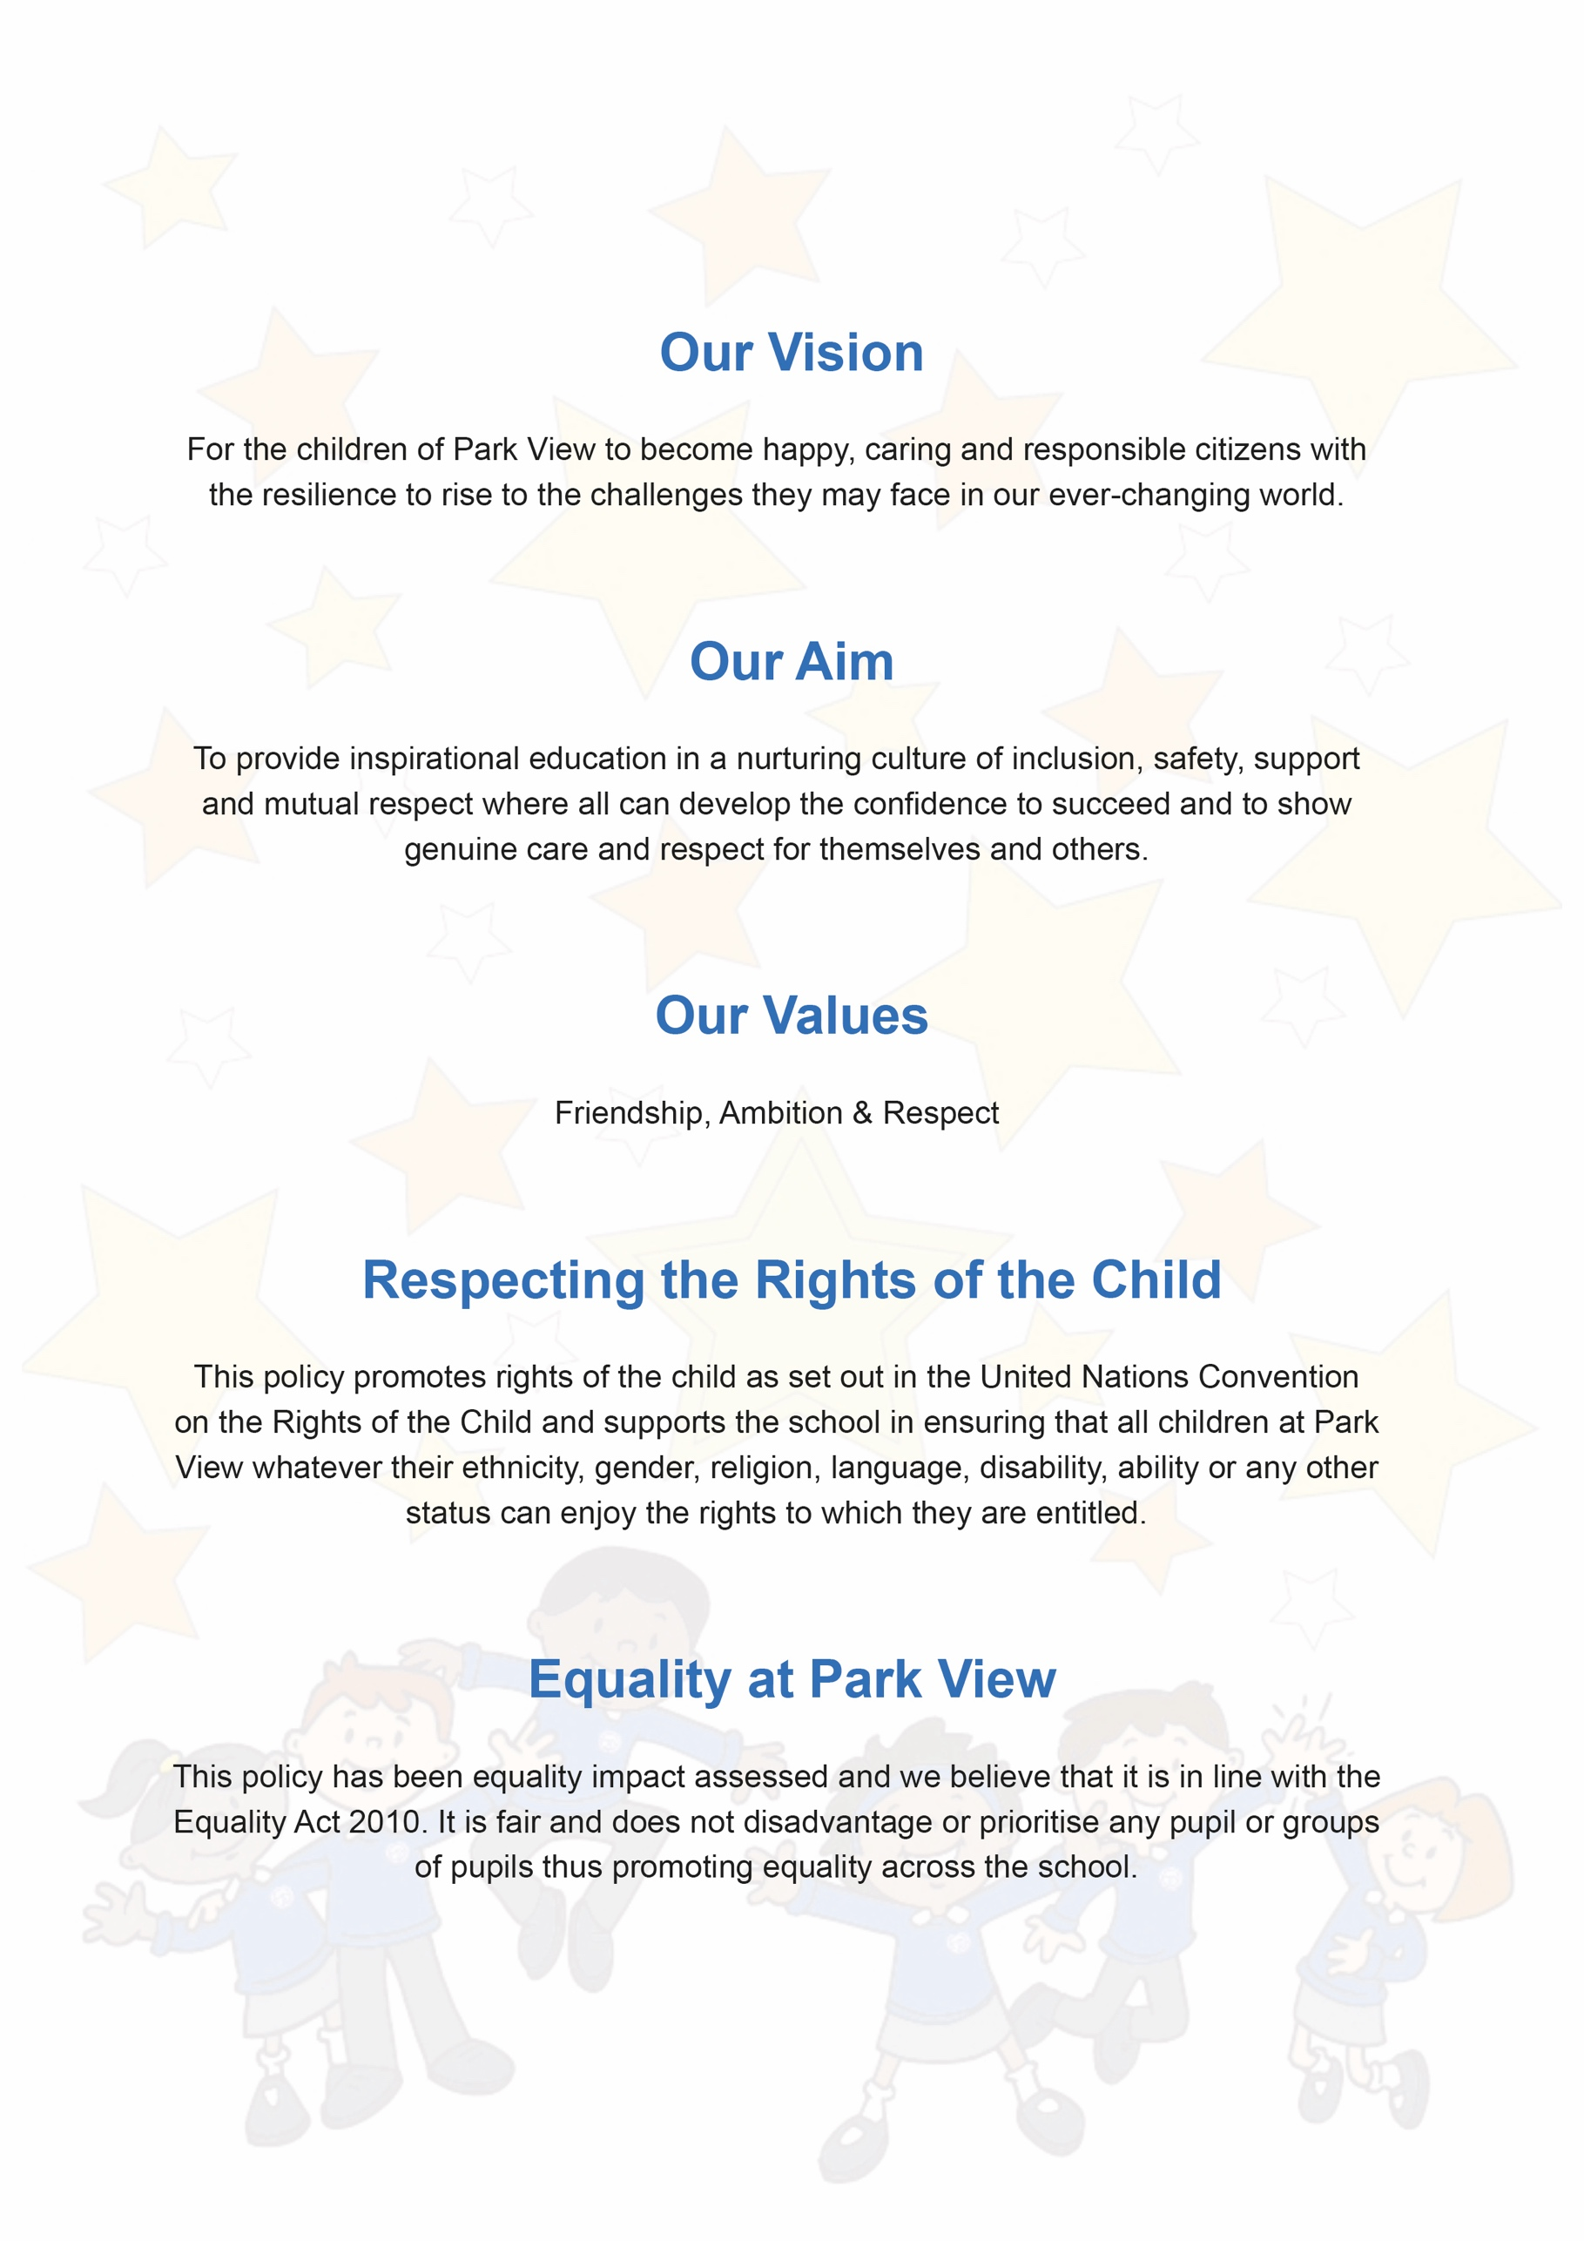

Contents
Aims | Page 4
Statutory Requirements | Page 4
Definition | Page 4
Curriculum | Page 4
Delivery of RSE | Page 5
Roles & Responsibilities | Page 5
Parental Rights | Page 6
Training & Support | Page 6
Monitoring Arrangements | Page 6

Document Control
Title | Relationships & Sex Education Policy
Date | September 2022
Supersedes | February 2022
Amendments | Information about initial consultation with parents removed
Related Policies/Guidance | PSHE Policy  Equality Statement
Review Date | September 2023

1. Aims
The aims of relationships and sex education (RSE) at our school are to:
- Provide a framework in which sensitive discussions can take place
- Prepare pupils for puberty, and give them an understanding of sexual development and the importance of health and hygiene
- Help pupils develop feelings of self-respect, confidence and empathy
- Create a positive culture around issues of sexuality and relationships
- Teach pupils the correct vocabulary to describe themselves and their bodies

2. Statutory requirements
As a maintained primary school we must provide relationships education to all pupils as per section 34 of the Children and Social work act 2017.
However, we are not required to provide sex education but we do need to teach the elements of sex education contained in the science curriculum.
In teaching RSE, we must have regard to guidance issued by the secretary of state as outlined in section 403 of the Education Act 1996.
At Park View Community School we teach RSE as set out in this policy.

3. Definition
RSE is about the emotional, social and cultural development of pupils, and involves learning about relationships, sexual health, sexuality, healthy lifestyles, diversity and personal identity.
RSE involves a combination of sharing information, and exploring issues and values.
RSE is not about the promotion of sexual activity.

4. Curriculum
Our RSE curriculum is part of the wider PHSE programme with the non-compulsory element relating to human reproduction covered in Y6.
Staff have the autonomy to adapt the curriculum according to the needs and age of the pupils they teach.
If pupils ask questions outside the scope of this policy, teachers will respond in an appropriate manner so they are fully informed and do not seek answers online.
Primary sex education will focus on:
- Preparing boys and girls for the changes that adolescence brings
- How a baby is conceived and born

5. Delivery of RSE
RSE is taught within the personal, social, health and economic (PSHE) education curriculum. Biological aspects of RSE are taught within the science curriculum, and other aspects are included in religious education (RE).
Pupils also receive stand-alone sex education sessions delivered by a trained health professional.
Relationships education focuses on teaching the fundamental building blocks and characteristics of positive relationships including:
- Families and people who care for me
- Caring friendships
- Respectful relationships
- Online relationships
- Being safe

The science curriculum covers reproduction in mammals and is taught in Y5.
These areas of learning are taught within the context of family life taking care to ensure that there is no stigmatisation of children based on their home circumstances (families can include single parent families, LGBT parents, families headed by grandparents, adoptive parents, foster parents/carers amongst other structures) along with reflecting sensitively that some children may have a different structure of support around them (for example: looked after children or young carers).

6. Roles and responsibilities
6.1 The governing board
The governing board will approve the RSE policy, and hold the headteacher to account for its implementation.

6.2 The headteacher
The headteacher is responsible for ensuring that RSE is taught consistently across the school, and for managing requests to withdraw pupils from the non-statutory components of RSE (see section 8).

6.3 Staff
Staff are responsible for:
- Delivering RSE in a sensitive way
- Modelling positive attitudes to RSE
- Monitoring progress
- Responding to the needs of individual pupils
- Responding appropriately to pupils whose parents wish them to be withdrawn from the non-statutory components of RSE
Staff do not have the right to opt out of teaching RSE. Staff who have concerns about teaching RSE are encouraged to discuss this with the headteacher.
The Y6 staff are responsible for teaching RSE at Park View with the support of members of the Inclusion Team if needed.

6.4 Pupils
Pupils are expected to engage fully in RSE and, when discussing issues related to RSE, treat others with respect and sensitivity.

7. Parents’ right to withdraw
Parents do not have the right to withdraw their children from relationships education.
Parents do have the right to withdraw their children from the non-statutory components of sex education within RSE.
Parents will be invited to an online sex education lesson prior to it being taught and all parents will receive a letter summarising this section of the policy with a form to complete should they choose to withdraw their child from the sex education session.
Alternative work will be given to pupils who are withdrawn from sex education.

8. Training and Support
Staff are involved in CPD relating to the teaching of RSE.
The headteacher may also invite visitors from outside the school, such as school nurses or sexual health professionals, to provide support and training to staff teaching RSE as necessary.

9. Monitoring arrangements
The delivery of RSE is monitored by the PSHE lead and the headteacher through:
Pupils’ development in RSE is monitored by class teachers as part of our internal assessment systems.
This policy will be reviewed by the headteacher annually. At every review, the policy will be approved by the governing board.

