HEALTH AND SAFETY POLICY

March 2023

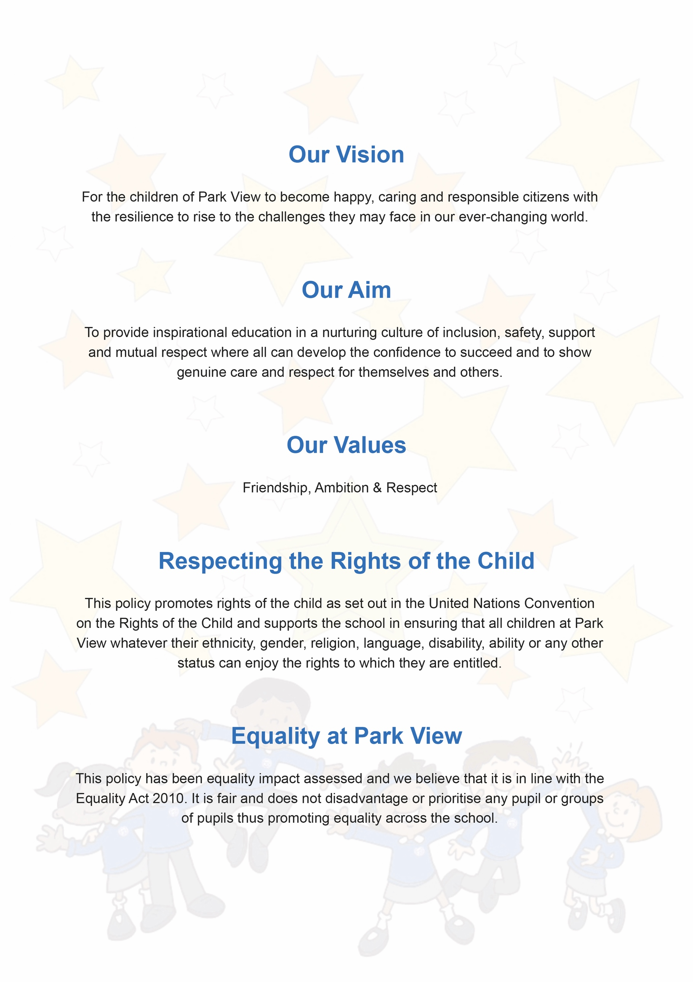

Contents
- Aims | 5
- Legislation | 5
- Roles and responsibilities | 6
- Site security | 7
- Fire | 7
- COSHH | 8
- Equipment | 9
- Lone working | 11
- Working at height | 11
- Manual handling | 11
- Off-site visits | 12
- Lettings | 12
- Violence at work | 12
- Smoking | 12
- Infection prevention and control | 13
- New and expectant mothers | 15
- Occupational stress | 15
- Accident reporting | 15
- Training | 17
- Monitoring | 17
- Links with other policies | 17
Appendix 1: Fire safety checklist | 18
Appendix 2: Accident report | 19
Appendix 3: Recommended absence period for preventing the spread of infection | 20

Document Control
Title
Date
Supersedes
Amendments
Related Policies/Guidance
Review Date

1. Aims
Our school aims to:
- Provide and maintain a safe and healthy environment
- Establish and maintain safe working procedures amongst staff, pupils and all visitors to the school site
- Have robust procedures in place in case of emergencies
- Ensure that the premises and equipment are maintained safely, and are regularly inspected

2. Legislation
This policy is based on advice from the Department for Education on health and safety in schools and the following legislation:
- The Health and Safety at Work etc. Act 1974, which sets out the general duties employers have towards employees and duties relating to lettings
- The Management of Health and Safety at Work Regulations 1992, which require employers to make an assessment of the risks to the health and safety of their employees
- The Management of Health and Safety at Work Regulations 1999, which require employers to carry out risk assessments, make arrangements to implement necessary measures, and arrange for appropriate information and training
- The Control of Substances Hazardous to Health Regulations 2002, which require employers to control substances that are hazardous to health
- The Reporting of Injuries, Diseases and Dangerous Occurrences Regulations (RIDDOR) 2013, which state that some accidents must be reported to the Health and Safety Executive and set out the timeframe for this and how long records of such accidents must be kept
- The Health and Safety (Display Screen Equipment) Regulations 1992, which require employers to carry out digital screen equipment assessments and states users’ entitlement to an eyesight test
- The Gas Safety (Installation and Use) Regulations 1998, which require work on gas fittings to be carried out by someone on the Gas Safe Register
- The Regulatory Reform (Fire Safety) Order 2005, which requires employers to take general fire precautions to ensure the safety of their staff
- The Work at Height Regulations 2005, which requires employers to protect their staff from falls from height
The school follows national guidance published by Public Health England when responding to infection control issues.
Sections of this policy are also based on the statutory framework for the Early Years Foundation Stage.

3. Roles and responsibilities
3.1 The local authority and governing board
Manchester City Council has ultimate responsibility for health and safety matters in the school, but delegates responsibility for the strategic management of such matters to the school’s governing board.
The governing board delegates operational matters and day-to-day tasks to the headteacher and staff members.

3.2 Headteacher
The headteacher is responsible for health and safety day-to-day. This involves:
- Implementing the health and safety policy
- Ensuring there is enough staff to safely supervise pupils
- Ensuring that the school building and premises are safe and regularly inspected
- Providing adequate training for school staff
- Reporting to the governing board on health and safety matters
- Ensuring appropriate evacuation procedures are in place and regular fire drills are held
- Ensuring that in their absence, health and safety responsibilities are delegated to another member of staff
- Ensuring all risk assessments are completed and reviewed
- Monitoring cleaning contracts, and ensuring cleaners are appropriately trained and have access to personal protective equipment, where necessary
In the headteacher’s absence, the deputy headteacher assumes the above day-to-day health and safety responsibilities.

3.3 Health and safety lead
The nominated health and safety lead is the headteacher and school business manager who have been granted the authority to delegate checks to the school caretaker who reports directly to her.

3.4 Staff
School staff have a duty to take care of pupils in the same way that a prudent parent would do so.
Staff will:
- Take reasonable care of their own health and safety and that of others who may be affected by what they do at work
- Co-operate with the school on health and safety matters
- Work in accordance with training and instructions
- Inform the appropriate person of any work situation representing a serious and immediate danger so that remedial action can be taken
- Model safe and hygienic practice for pupils
- Understand emergency evacuation procedures and feel confident in implementing them
3.5 Pupils and parents
Pupils and parents are responsible for following the school’s health and safety advice, on-site and off-site, and for reporting any health and safety incidents to a member of staff.

3.6 Contractors
Contractors will agree health and safety practices with the school’s nominated contact for contractors (Mr S Fairhurst ) before starting work. All contractors will be given a copy of the school’s Handbook for Contractors. Before work begins the contractor will provide evidence that they have completed an adequate risk assessment of all their planned work.

4. Site security
The caretaker, is responsible for the security of the school site in and out of school hours. They are responsible for visual inspections of the site, and for the intruder and fire alarm systems.
The headteacher, business manager, caretaker and deputy caretaker are key holders and will respond to an emergency.

5. Fire
Emergency exits, assembly points and assembly point instructions are clearly identified by safety signs and notices. Fire risk assessment of the premises will be reviewed regularly.
Emergency evacuations are practised at least once a term.
The fire alarm is a loud continuous bell.
Fire alarm testing will take place once every week.
New staff will be trained in fire safety and all staff and pupils will be made aware of any new fire risks.
In the event of a fire:
- The alarm will be raised immediately by whoever discovers the fire and emergency services contacted by a member of the admin team. Evacuation procedures will also begin immediately
- Fire extinguishers may be used by staff only, and only then if staff are trained in how to operate them and are confident they can use them without putting themselves or others at risk
- Staff and pupils will congregate at the assembly points on the astroturf.
- Class teachers will take a register of pupils, which will then be checked against the attendance register of that day
- The business manager will take a register of all staff.
- Staff and pupils will remain outside the building until the emergency services say it is safe to re-enter.
The school will have special arrangements in place for the evacuation of people with mobility needs and fire risk assessments will also pay particular attention to those with disabilities which are outlined in the Personal Emergency Evacuation Plans (PEEPS)
A fire safety checklist can be found in appendix 1.

6. COSHH
Schools are required to control hazardous substances, which can take many forms, including:
- Chemicals
- Products containing chemicals
- Fumes
- Dusts
- Vapours
- Mists
- Gases and asphyxiating gases
- Germs that cause diseases, such as leptospirosis or legionnaires disease
Control of substances hazardous to health (COSHH) risk assessments are completed by the caretaker and circulated to all employees who work with hazardous substances. Staff will also be provided with protective equipment, where necessary.

Our staff use and store hazardous products in accordance with instructions on the product label. All hazardous products are kept in their original containers, with clear labelling and product information.

Any hazardous products are disposed of in accordance with specific disposal procedures.
Emergency procedures, including procedures for dealing with spillages, are displayed near where hazardous products are stored and in areas where they are routinely used.

6.1 Gas safety
- Installation, maintenance and repair of gas appliances and fittings will be carried out by a competent Gas Safe registered engineer
- Gas pipework, appliances and flues are regularly maintained
- All rooms with gas appliances are checked to ensure that they have adequate ventilation
6.2 Legionella
- A water risk assessment is completed monthly by Total Water Services Ltd. The Site Manager is responsible for ensuring that the identified operational controls are conducted and recorded in the school’s water log book
- This risk assessment will be reviewed every year and when significant changes have occurred to the water system and/or building footprint
- The risks from legionella are mitigated by the following: Weekly checks by Caretaker, monthly temperature checks by Total Water Services and annual service.
6.3 Asbestos
- The school building is a new-build completed in 2010 and does not have any asbestos.

7. Equipment
- All equipment and machinery is maintained in accordance with the manufacturer’s instructions. In addition, maintenance schedules outline when extra checks should take place
- When new equipment is purchased, it is checked to ensure that it meets appropriate educational standards
- All equipment is stored in the appropriate storage containers and areas. All containers are labelled with the correct hazard sign and contents
7.1 Electrical equipment
- All staff are responsible for ensuring that they use and handle electrical equipment sensibly and safely
- Any pupil or volunteer who handles electrical appliances does so under the supervision of the member of staff who so directs them
- Any potential hazards will be reported to Mr S Fairhurst immediately and in his absence to Miss L Day.
- Permanently installed electrical equipment is connected through a dedicated isolator switch and adequately earthed
- Only trained staff members can check plugs
- Where necessary a portable appliance test (PAT) will be carried out by a competent person
- All isolators switches are clearly marked to identify their machine
- Electrical apparatus and connections will not be touched by wet hands and will only be used in dry conditions
- Maintenance, repair, installation and disconnection work associated with permanently installed or portable electrical equipment is only carried out by a competent person
7.2 PE equipment
- Pupils are taught how to carry out and set up PE equipment safely and efficiently. Staff check that equipment is set up safely
- Any concerns about the condition of the gym floor or other apparatus will be reported to the caretaker and to the PE leader
7.3 Display screen equipment
- All staff who use computers daily as a significant part of their normal work have a display screen equipment (DSE) assessment carried out. ‘Significant’ is taken to be continuous/near continuous spells of an hour or more at a time
- Staff identified as DSE users are entitled to an eyesight test for DSE use upon request, and at regular intervals thereafter, by a qualified optician (and corrective glasses provided if required specifically for DSE use)
7.4 Specialist equipment
Parents are responsible for the maintenance and safety of their children’s wheelchairs. In school, staff promote the responsible use of wheelchairs.
Oxygen cylinders are stored in a designated space, and staff are trained in the removal storage and replacement of oxygen cylinders.

8. Lone working
Lone working may include:
- Late working
- Home or site visits
- Weekend working
- Site manager duties
- Site cleaning duties
- Working in a single occupancy office
Potentially dangerous activities, such as those where there is a risk of falling from height, will not be undertaken when working alone. If there are any doubts about the task to be performed then the task will be postponed until other staff members are available.
If lone working is to be undertaken, a colleague, friend or family member will be informed about where the member of staff is and when they are likely to return.
The lone worker will ensure that they are medically fit to work alone.

9. Working at height
We will ensure that work is properly planned, supervised and carried out by competent people with the skills, knowledge and experience to do the work.
In addition:
- The caretaker retains ladders for working at height
- Pupils are prohibited from using ladders
- Staff will wear appropriate footwear and clothing when using ladders
- Contractors are expected to provide their own ladders for working at height
- Before using a ladder, staff are expected to conduct a visual inspection to ensure its safety
- Access to high levels, such as roofs, is only permitted by trained persons

10. Manual handling
It is up to individuals to determine whether they are fit to lift or move equipment and furniture. If an individual feels that to lift an item could result in injury or exacerbate an existing condition, they will ask for assistance.
The school will ensure that proper mechanical aids and lifting equipment are available in school, and that staff are trained in how to use them safely.
Staff and pupils are expected to use the following basic manual handling procedure:
- Plan the lift and assess the load. If it is awkward or heavy, use a mechanical aid, such as a trolley, or ask another person to help
- Take the more direct route that is clear from obstruction and is as flat as possible
- Ensure the area where you plan to offload the load is clear
- When lifting, bend your knees and keep your back straight, feet apart and angled out. Ensure the load is held close to the body and firmly. Lift smoothly and slowly and avoid twisting, stretching and reaching where practicable

11. Off-site visits
When taking pupils off the school premises, we will ensure that:
- Risk assessments will be completed where off-site visits and activities require them
- All off-site visits are appropriately staffed
- Staff will take a school mobile phone, a portable first aid kit, information about the specific medical needs of pupils along with the parents’ contact details
- There will always be at least one first aider on school trips and visits
For EYFS:
- There will always be at least one first aider with a current paediatric first aid certificate on school trips and visits, as required by the statutory framework for the Early Years Foundation Stage.

12. Lettings
This policy applies to lettings. Those who hire any aspect of the school site or any facilities will be made aware of the content of the school’s health and safety policy, and will have responsibility for complying with it.

13. Violence at work
We believe that staff should not be in any danger at work, and will not tolerate violent or threatening behaviour towards our staff.
All staff will report any incidents of aggression or violence (or near misses) directed to themselves to their line manager/headteacher immediately. This applies to violence from pupils, visitors or other staff.

14. Smoking
Smoking is not permitted anywhere on the school premises.

15. Infection prevention and control
We follow national guidance published by Public Health England (PHE) when responding to infection control issues. We will encourage staff and pupils to follow this good hygiene practice, outlined below, where applicable.

15.1 Handwashing
- Wash hands with liquid soap and warm water, and dry with air dryers/paper towels
- Always wash hands after using the toilet, before eating or handling food, and after handling animals
- Cover all cuts and abrasions with waterproof dressings
15.2 Coughing and sneezing
- Cover mouth and nose with a tissue
- Wash hands after using or disposing of tissues
- Spitting is discouraged
15.3 Personal protective equipment
- Wear disposable non-powdered vinyl or latex-free CE-marked gloves and disposable plastic aprons where there is a risk of splashing or contamination with blood/body fluids (for example, nappy or pad changing)
- Wear goggles if there is a risk of splashing to the face
- Use the correct personal protective equipment when handling cleaning chemicals
15.4 Cleaning of the environment
- Clean the environment, including toys and equipment, frequently and thoroughly
15.5 Cleaning of blood and body fluid spillages
- Clean up all spillages of blood, faeces, saliva, vomit, nasal and eye discharges immediately and wear personal protective equipment
- When spillages occur, clean using a product that combines both a detergent and a disinfectant and use as per manufacturer’s instructions. Ensure it is effective against bacteria and viruses and suitable for use on the affected surface
- Never use mops for cleaning up blood and body fluid spillages – use disposable paper towels and discard clinical waste as described below
- Make spillage kits available for blood spills

15.6 Laundry
- Wash laundry in a separate dedicated facility
- Wash soiled linen separately and at the hottest wash the fabric will tolerate
- Wear personal protective clothing when handling soiled linen
- Bag children’s soiled clothing to be sent home, never rinse by hand
15.7 Clinical waste
- Always segregate domestic and clinical waste, in accordance with local policy
- Used nappies/pads, gloves, aprons and soiled dressings are stored in correct clinical waste bags in foot-operated bins
- Remove clinical waste with a registered waste contractor
- Remove all clinical waste bags when they are two-thirds full and store in a dedicated, secure area while awaiting collection
15.8 Animals
- Wash hands before and after handling any animals
- Keep animals’ living quarters clean and away from food areas
- Dispose of animal waste regularly, and keep litter boxes away from pupils
- Supervise pupils when playing with animals
- Seek veterinary advice on animal welfare and animal health issues, and the suitability of the animal as a pet
15.9 Pupils vulnerable to infection
Some medical conditions make pupils vulnerable to infections that would rarely be serious in most children. The school will normally have been made aware of such vulnerable children. These children are particularly vulnerable to chickenpox, measles or slapped cheek disease (parvovirus B19) and, if exposed to either of these, the parent/carer will be informed promptly and further medical advice sought. Advise these children to have additional immunisations, for example for pneumococcal and influenza.

15.10 Exclusion periods for infectious diseases
The school will follow recommended exclusion periods outlined by Public Health England, summarised in appendix 3.
In the event of an epidemic/pandemic, we will follow advice from Public Health England about the appropriate course of action.

16. New and expectant mothers
Risk assessments will be carried out whenever any employee or pupil notifies the school that they are pregnant.
Appropriate measures will be put in place to control risks identified. Some specific risks are summarised below:
- Chickenpox can affect the pregnancy if a woman has not already had the infection. Expectant mothers should report exposure to antenatal carer and GP at any stage of exposure. Shingles is caused by the same virus as chickenpox, so anyone who has not had chickenpox is potentially vulnerable to the infection if they have close contact with a case of shingles
- If a pregnant woman comes into contact with measles or German measles (rubella), she should inform her antenatal carer and GP immediately to ensure investigation
- Slapped cheek disease (parvovirus B19) can occasionally affect an unborn child. If exposed early in pregnancy (before 20 weeks), the pregnant woman should inform her antenatal care and GP as this must be investigated promptly

17. Occupational stress
We are committed to promoting high levels of health and wellbeing and recognise the importance of identifying and reducing workplace stressors through risk assessment.
Systems are in place within the school for responding to individual concerns and monitoring staff workloads.

18. Accident reporting

18.1 Accident records
- An accident form will be completed as soon as possible after the accident occurs by the member of staff or first aider who deals with it. An accident form template can be found in appendix 2. The information from the accident form will be logged onto the schools electronic system and the original form sent home with the child for parental reference.

- As much detail as possible will be supplied when reporting an accident
- Information about injuries will also be kept in the pupil’s educational record
- Records held in the first aid and accident log will be retained by the school for a minimum of 3 years, in accordance with regulation 25 of the Social Security (Claims and Payments) Regulations 1979, and then securely disposed of.

18.2 Reporting to the Health and Safety Executive
The Nominated person for first aid will keep a record of any accident which results in a reportable injury, disease, or dangerous occurrence as defined in the RIDDOR 2013 legislation (regulations 4, 5, 6 and 7).

The Nominated Person for first aid will report these to the Health and Safety Executive as soon as is reasonably practicable and in any event within 10 days of the incident.
Reportable injuries, diseases or dangerous occurrences include:
- Death
- Specified injuries. These are:
  - Fractures, other than to fingers, thumbs and toes
  - Amputations
  - Any injury likely to lead to permanent loss of sight or reduction in sight
  - Any crush injury to the head or torso causing damage to the brain or internal organs
  - Serious burns (including scalding)
  - Any scalping requiring hospital treatment
  - Any loss of consciousness caused by head injury or asphyxia
  - Any other injury arising from working in an enclosed space which leads to hypothermia or heat-induced illness, or requires resuscitation or admittance to hospital for more than 24 hours

- Injuries where an employee is away from work or unable to perform their normal work duties for more than 7 consecutive days
- Where an accident leads to someone being taken to hospital
- Where something happens that does not result in an injury, but could have done
- Near-miss events that do not result in an injury, but could have done. Examples of near-miss events relevant to schools include, but are not limited to:
  - The collapse or failure of load-bearing parts of lifts and lifting equipment
  - The accidental release of a biological agent likely to cause severe human illness
  - The accidental release or escape of any substance that may cause a serious injury or damage to health
  - An electrical short circuit or overload causing a fire or explosion

Information on how to make a RIDDOR report is available here:
How to make a RIDDOR report, HSE
http://www.hse.gov.uk/riddor/report.htm

18.3 Notifying parents
The First Aid Leader will inform parents of any accident or injury sustained by a pupil, and any first aid treatment given, on the same day, or as soon as reasonably practicable.

18.4 Reporting to Ofsted and child protection agencies
The Headteacher will notify Ofsted of any serious accident, illness or injury to, or death of, a pupil while in the school’s care. This will happen as soon as is reasonably practicable, and no later than 14 days after the incident.
The Headteacher (with the school safeguarding leader) will also notify Manchester Children’s Services of any serious accident or injury to, or the death of, a pupil while in the school’s care.

19. Training
Our staff are provided with health and safety training as part of their induction process.
Staff who work in high risk environments, such as in science labs or with woodwork equipment, or work with pupils with special educational needs (SEND), are given additional health and safety training.

20. Monitoring
This policy will be reviewed by the headteacher every two years.
At every review, the policy will be approved by the board of governors.

21. Links with other policies
This health and safety policy links to the following policies:
- First aid
- Risk assessment
- Supporting pupils with medical conditions
- Accessibility plan

Appendix 1. Fire safety checklist

Issue to check | Yes/No
Are fire regulations prominently displayed?
Is fire-fighting equipment, including fire blankets, in place?
Does fire-fighting equipment give details for the type of fire it should be used for?
Are fire exits clearly labelled?
Are fire doors fitted with self-closing mechanisms?
Are flammable materials stored away from open flames?
Do all staff and pupils understand what to do in the event of a fire?
Can you easily hear the fire alarm from all areas?

Appendix 2. Accident and Illness Record Form
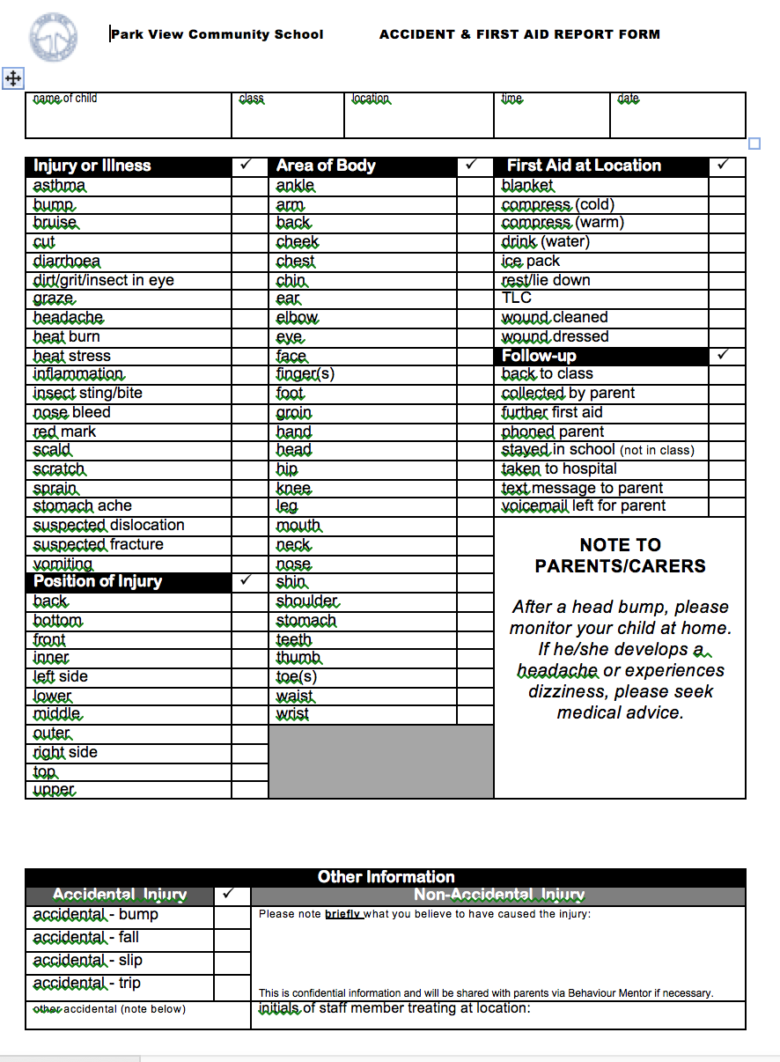

Appendix 3 Recommended absence period for preventing the spread of infection
This list of recommended absence periods for preventing the spread of infection is taken from
non-statutory guidance for schools and other childcare settings from Public Health England (PHE).

Rashes and Skin Infections

Infection or complaint | Recommended period to be kept away from school or nursery | Comments
Athlete’s foot | None | Athlete’s foot is not a serious condition. Treatment is recommended.
Chickenpox | Until all vesicles have crusted over | Some medical conditions make children vulnerable to infections that would rarely be serious in most children, these include those being treated for leukaemia or other cancers. These children are particularly vulnerable to chickenpox. Chickenpox can also affect pregnancy if a woman has not already had the infection.
Cold sores (herpes simplex) | None | Avoid kissing and contact with the sores. Cold sores are generally mild and self-limiting.
German measles (rubella)* | Four days from onset of rash (as per “Green Book”) | Preventable by immunisation (MMR x2 doses). If a pregnant woman comes into contact with German measles she should inform her GP and antenatal carer immediately to ensure investigation.
Hand, foot and mouth | None
Impetigo | Until lesions are crusted and healed, or 48 hours after starting antibiotic treatment | Antibiotic treatment speeds healing and reduces the infectious period.
Measles* | Four days from onset of rash | Preventable by immunisation (MMR x2 doses). Some medical conditions make children vulnerable to infections that would rarely be serious in most children, these include those being treated for leukaemia or other cancers. These children are particularly vulnerable to measles. Measles during pregnancy can result in early delivery or even loss of the baby. If a pregnant woman is exposed she should immediately inform whoever is giving antenatal care to ensure investigation.
Molluscum contagiosum | None | A self-limiting condition.
Ringworm | Exclusion not usually required | Treatment is required.
Roseola (infantum) | None
Scabies | Child can return after first treatment | Household and close contacts require treatment.
Scarlet fever* | Child can return 24 hours after starting appropriate antibiotic treatment | Antibiotic treatment is recommended for the affected child.
Slapped cheek syndrome/fifth disease (parvovirus B19) | None (once rash has developed) | Some medical conditions make children vulnerable to infections that would rarely be serious in most children, these include those being treated for leukaemia or other cancers. These children are particularly vulnerable to parvovirus B19. Slapped cheek disease (parvovirus B19) can occasionally affect an unborn child. If exposed early in pregnancy (before 20 weeks), inform whoever is giving antenatal care as this must be investigated promptly.
Shingles | Exclude only if rash is weeping and cannot be covered | Can cause chickenpox in those who are not immune, i.e. have not had chickenpox. It is spread by very close contact and touch. If further information is required, contact your local PHE centre. Some medical conditions make children vulnerable to infections that would rarely be serious in most children, these include those being treated for leukaemia or other cancers. These children are particularly vulnerable to shingles. Shingles can also affect pregnancy if a woman has not already had chickenpox.
Warts and verrucae | None | Verrucae should be covered in swimming pools, gymnasiums and changing rooms.

Diarrhoea and vomiting illness

Infection or complaint | Recommended period to be kept away from school or nursery | Comments
Diarrhoea and/or vomiting | 48 hours from last episode of diarrhoea or vomiting
E. coli O157 VTEC  Typhoid* [and paratyphoid*] (enteric fever) Shigella (dysentery) | Should be excluded for 48 hours from the last episode of diarrhoea. Further exclusion may be required for some children until they are no longer excreting | Further exclusion is required for children aged 5 years or younger and those who have difficulty in adhering to hygiene practices. Children in these categories should be excluded until there is evidence of microbiological clearance. This guidance may also apply to some contacts who may also require microbiological clearance. Please consult your local PHE centre for further advice
Cryptosporidiosis | Exclude for 48 hours from the last episode of diarrhoea | Exclusion from swimming is advisable for two weeks after the diarrhoea has settled

Respiratory Infections

Infection or complaint | Recommended period to be kept away from school or nursery | Comments
Flu (influenza) | Until recovered | Some medical conditions make children vulnerable to infections that would rarely be serious in most children, these include those being treated for leukaemia or other cancers. It may be advisable for these children to have additional immunisations, for example pneumococcal and influenza.
Tuberculosis* | Always consult your local PHE centre | Some medical conditions make children vulnerable to infections that would rarely be serious in most children, these include those being treated for leukaemia or other cancers. It may be advisable for these children to have additional immunisations, for example pneumococcal and influenza.
Whooping cough* | Five days from starting antibiotic treatment, or 21 days from onset of illness if no antibiotic treatment | Preventable by vaccination. After treatment, non-infectious coughing may continue for many weeks. Your local PHE centre will organise any contact tracing necessary.

Other infections

Infection or complaint | Recommended period to be kept away from school or nursery | Comments
Conjunctivitis | None | If an outbreak/cluster occurs, consult your local PHE centre.
Diphtheria* | Exclusion is essential. Always consult with your local HPT | Family contacts must be excluded until cleared to return by your local PHE centre. Preventable by vaccination. Your local PHE centre will organise any contact tracing necessary.
Glandular fever | None
Head lice | None | Treatment is recommended only in cases where live lice have been seen.
Conjunctivitis | None | If an outbreak/cluster occurs, consult your local PHE centre.
Diphtheria* | Exclusion is essential. Always consult with your local HPT | Family contacts must be excluded until cleared to return by your local PHE centre. Preventable by vaccination. Your local PHE centre will organise any contact tracing necessary.
Meningococcal meningitis*/ septicaemia* | Until recovered | Meningitis C is preventable by vaccination There is no reason to exclude siblings or other close contacts of a case. In case of an outbreak, it may be necessary to provide antibiotics with or without meningococcal vaccination to close school contacts. Your local PHE centre will advise on any action is needed.
Meningitis* due to other bacteria | Until recovered | Hib and pneumococcal meningitis are preventable by vaccination. There is no reason to exclude siblings or other close contacts of a case. Your local PHE centre will give advice on any action needed.
Meningitis viral* | None | Milder illness. There is no reason to exclude siblings and other close contacts of a case. Contact tracing is not required.
MRSA | None | Good hygiene, in particular handwashing and environmental cleaning, are important to minimise any danger of spread. If further information is required, contact your local PHE centre.
Mumps* | Exclude child for five days after onset of swelling | Preventable by vaccination
Threadworms | None | Treatment is recommended for the child and household contacts.
Tonsillitis | None | There are many causes, but most cases are due to viruses and do not need an antibiotic.

* denotes a notifiable disease. It is a statutory requirement that doctors report a notifiable disease to the proper officer of the local authority (usually a consultant in communicable disease control). In addition, organisations may be required via locally agreed arrangements to inform their local PHE centre. Regulating bodies (for example, Ofsted/Commission for Social Care Inspection (CSCI)) may wish to be informed.

