Anti-Bullying Policy

March 2023

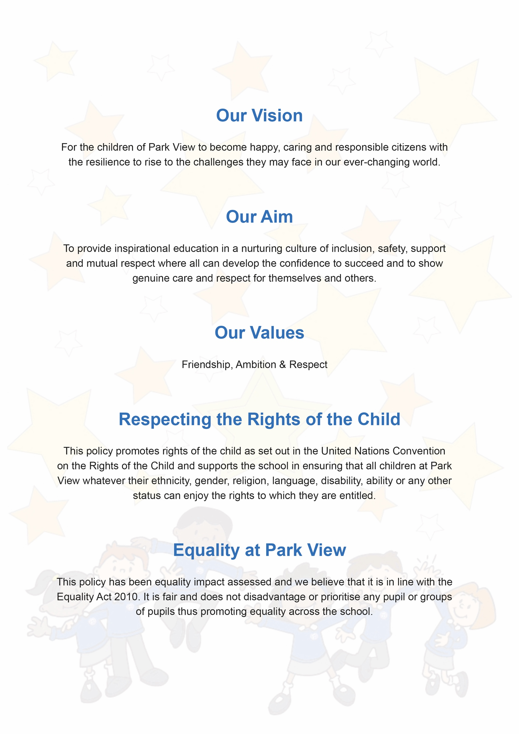

Contents
Our Statement of Intent | Page 4
What is Bullying? | Page 4
Several Times On Purpose | Page 4
Why is it Important to Respond to Bullying? | Page 5
Signs and Symptoms | Page 5/6
Procedures | Page 6
Outcomes | Page 6
Prevention | Page 7

Document Control
Title | Anti-Bullying Policy
Date | June 2022
Supersedes | March 2021
Amendments | The term homophobic replaced by LGBTQ+  Document control section moved here.
Related Policies/Guidance | Restorative Practice Behaviour Management Policy  Suspensions & Exclusions Policy  Safeguarding Policy
Review Date | June 2024

Our Statement of Intent
At Park View committed to providing a caring, friendly and safe environment for all of our pupils so they can learn in a relaxed and secure atmosphere. Bullying of any kind is unacceptable at our school. If bullying does occur, all pupils should be able to tell and know that incidents will be dealt with promptly and effectively. We are a TELLING school. This means that anyone who knows that bullying is happening is expected to tell the staff.
What Is Bullying?
Bullying is the use of aggression with the intention of hurting another person. Bullying results in pain and distress to the victim. Bullying can be:
• Emotional
• Physical
• Racist
• Sexual
• LGBTQ+
• Verbal
• Cyber
Bullying is not when friends disagree, fall-out or have arguments. It is not one-off acts of aggression (though these are considered serious and are addressed in our Behaviour Management Policy).
At Park View we consider bullying to be actions that are:
Several Times On Purpose
Bullying is when a child or children fully understand what they are doing know the affect they are having on the victim.
Why is it Important to Respond to Bullying?
Bullying hurts. No one deserves to be a victim of bullying. Everybody has the right to be treated with respect. Pupils who are bullying need to learn different ways of behaving.
At Park View all staff have a responsibility to respond promptly and effectively to issues of bullying.
Policy Aims
To ensure that:
- all governors, staff, children and parents/carers have an understanding of what bullying is
- all governors and staff know what the school’s procedures for dealing with bullying and follow it when bullying is reported
- all children and parents/carers should know the school’s procedures for dealing with bullying and what they should do if bullying arises
As a school we take bullying seriously. Children and parents/carers should be assured that they will be supported when bullying is reported. Bullying will not be tolerated.
Signs and Symptoms
A child may indicate by signs or behaviour that he or she is being bullied. Adults should be aware of these possible signs and that they should investigate if a child:
•is frightened of walking to or from school
•doesn't want to go on the school / public bus
•begs to be driven to school
•changes their usual routine
•is unwilling to go to school (school phobic)
•begins to truant
•becomes withdrawn anxious, or lacking in confidence
•starts stammering
•attempts or threatens suicide or runs away
•cries themselves to sleep at night or has nightmares
•feels ill in the morning
•begins to do poorly in school work
•comes home with clothes torn or books damaged
•has possessions which are damaged or " go missing"
•asks for money or starts stealing money (to pay bully)
•has dinner or other monies continually "lost"
•has unexplained cuts or bruises
•comes home starving (money / lunch has been stolen)
•becomes aggressive, disruptive or unreasonable
•is bullying other children or siblings
•stops eating
•is frightened to say what's wrong
•gives improbable excuses for any of the above
•is afraid to use the internet or mobile phone
•is nervous & jumpy when a cyber-message is received
These signs and behaviours could indicate other problems such as abuse or neglect, but bullying should be considered a possibility and should be investigated.
Procedures
- When an incident of bullying is reported – it is fully investigated by a member of staff as soon as possible (this is likely to be the Behaviour Mentor but could be any member of staff or member of the Senior Leadership Team).
- Outcomes of the investigation are recorded on CPOMS using the categories already in the system (alleged bullying, actual bullying, bullying aggressor, bullying victim).
- Sanctions will be put in place for bullying aggressor (as outlined in the Behaviour Management Policy) which includes, time out/time in isolation during break/lunch to reflect on actions and consider the next steps to put it right.
- In serious cases parents should be informed and will be asked to attend a meeting to discuss the problem.
Outcomes
1. The bully (bullies) will be asked to genuinely apologise and make amends to the victim(s) by taking responsibility for what he/she/they have done.
2. In serious cases, exclusion will be considered.
3. If possible, the pupils will be reconciled and if necessary nurture and supportive work with the Behaviour Mentor will be planned and delivered.
- After the incident / incidents have been investigated and dealt with, each case will be monitored to ensure repeated bullying does not take place.

Prevention
We use methods for helping children to prevent bullying which include:
•The Park View Code (this highlights how we expect children and adults to behave in school)
•The Park View Promise (based on our code, all staff and children make this promise out loud in assemblies and at other times during the school week)
•Class sessions about empathy and effects of our actions ((in PHSE sessions/circle time)
•Whole school and phase assemblies
•Themed assemblies (for example with PCSO)
•Extensive support and nurture from members of the inclusion team
We would like to acknowledge that this policy is based on recommended guidelines from KIDSCAPE.

