Young children (6-10)

Online safety advice
Early use of digital technology has been shown to improve language skills and promote children’s social development and creativity.
But it’s not without risks for young children, who may come across inappropriate content or begin to copy what older children do online. See our advice to understand what you can do to give young children the best experience of going online.

Agree boundaries
Be clear what your child can and can’t do online – where they can use the internet, how much time they can spend online, the sites they can visit and the type of information they can share. Agree with your child when they can have a mobile phone or tablet.

Explore together
The best way to find out what your child is doing online is to ask them to tell you about what they do and what sites they like to visit. If they’re happy to, ask them to show you. Talk to them about being a good friend online.

Put yourself in control
Install parental controls on your home broadband and any internet-enabled devices. Set up a user account for your child on the main device they use and make sure other accounts in the household are password-protected so that younger children can’t access them by accident.

Use airplane mode
Use airplane mode on your devices when your child is using them so they can’t make any unapproved purchases or interact with anyone online without your knowledge.

Stay involved
Encourage them to use their tech devices in a communal area like the lounge or kitchen so you can keep an eye on how they’re using the internet and also share in their enjoyment.

Talk to siblings
It’s also a good idea to talk to any older children about what they’re doing online and what they show to younger children. Encourage them to be responsible and help keep their younger siblings safe.

Search safely
Use safe search engines such as Swiggle or Kids-search. You can save time by adding these to your ‘Favourites’. Safe search settings can also be activated on Google and other search engines, as well as YouTube.

Check if it’s suitable
The age ratings that come with games, apps, films and social networks are a good guide to whether they’re suitable for your child. For example, the minimum age limit is 13 for several social networking sites, including Facebook and Instagram. Although sites aimed at under-10s like Spotlite (Formerly Kudos) also have social networking elements.

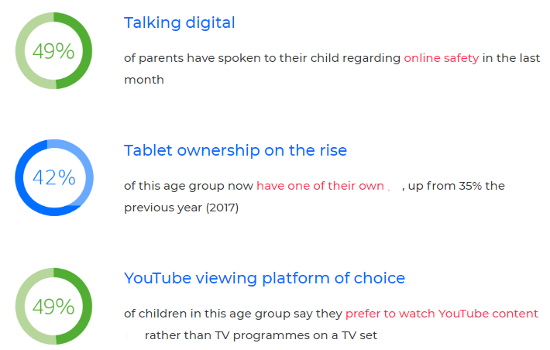
Why is it important?
Parent control
Visit:
https://www.internetmatters.org/parental-controls/
Many parents can be put off using controls and settings as they think they will be difficult to set up, or complicated to use. Click on the link for step by steps guides, they can help make it simple and straightforward for any device.
You can search parental controls for smartphones and other devices; entertainment & search engines; broadband & mobile networks; social media; and gaming consoles.
Guides to social network, apps and games

Visit:

https://www.net-aware.org.uk/

NSPCC NetAware has created simple guides for parents. The guides are for the most popular social networks, apps and games that children are using and what concerns to watch out for.

Age Rating
Age restrictions are put in place to stop those under the required age from being exposed to content which is intended for older users. There are two official ways you can check whether a particular game, app or film is appropriate. The BBFC and PEGI can both be used to check the content is appropriate for the child.

The British Board of Film Classification will inform you of the suitability of films and television. The BBFC can also provide additional warnings regarding the content such as language, adult imagery, violence, threat/horror, dangerous behaviour and anything else that might be deemed inappropriate for the child.
https://bbfc.co.uk/
PEGI (Pan European Games Information) is a content rating system that ensures all video games are labelled with a minimum age recommendation. The ratings are split into age restrictions and content descriptors to help parents understand what the game features.
https://pegi.info/

4 types of Risk
Content risks: The child or young person is exposed to harmful material.
Contact risks: The child or young person participates in adult initiated online activity.
Conduct risks: The child or young person is a perpetrator or victim in peer-to-peer exchange.
Commercial risks: The child or young person is exposed to inappropriate commercial advertising (including extremist content), marketing schemes or hidden costs.
Contact: Who do our children need to be aware of?
- Stranger danger: Not everyone online is who they say they are.
- Cyber-bullying in all forms
- Identity theft (including ‘frape’ (hacking Facebook profiles)) and sharing passwords
Content: What do our children need to be aware of?
-Exposure to inappropriate content.
-Ignoring age ratings in games (exposure to violence, offensive language).
Conduct: What do our children need to be aware of?
-Privacy issues, including disclosure of personal information.
-Digital footprint and online reputation
-Screen time
-Being share aware
Commercial: What do our children need to be aware of?
-Issues of advertisements on body image.
-Gambling
-Extremism and radicalisation
-Spam, pop – ups

Useful sites
www.nspcc.org.uk
www.net-aware.org.uk
www.internetmatters.org/
TALK TO SOMEONE ABOUT ONLINE SAFETY
Whether you want to set up parental controls, adjust privacy settings or get advice on social networks, experts from the free O2 & NSPCC helpline are here to help.
0808 800 5002
BBC Own It (Child friendly guidance)
https://www.bbc.com/ownit
Google: Internet Matters (Includes a game children can play based on e-safety)
https://beinternetawesome.withgoogle.com/en_us/

