EYFS (0-5)

Online safety advice
More and more pre-schoolers are using their parents’ computers, smartphones or tablets to play games, use apps, and watch their favourite TV shows. There are simple things you can do to make sure they’re using the internet safely.

Explore together
Talk to your child about what the internet is and explore it together so you can show them all the great fun and educational things they can do.

Put yourself in control
Install parental controls on your home broadband. Most Internet-enabled devices also allow you to set parental controls so you can m

Use passwords
Keep your devices out of reach and set passwords on all your internet-enabled devices and don’t share them. Then you’ll know when and where your child is accessing the internet. You can also make sure they’re not making additional purchases when they’re playing games or using apps.

Search safely
Use safe search engines such as Swiggle or Kids-search. You can save time by adding these to your ‘Favourites’. Safe search settings can also be activated on Google and other search engines, as well as YouTube.

Be involved
Encourage them to use devices in a communal area like the lounge or kitchen so you can keep an eye on how they’re using the internet and also share in their enjoyment.

Manage access
Set your homepage to a child-friendly site like CBeebies and create a user account for your child on the family computer or device which only allows access to sites you’ve chosen.

Help them learn through games
You can choose safe, fun and educational online games to play with your child and that you’ll be confident about them exploring. You can find good free of charge examples from Cbeebies and companies like Disney+, Nick Jr and Fisher Price.

Set boundaries
It’s never too early to start setting boundaries. Set some rules about how long your child can spend online.

Why it matters: Facts & Stats

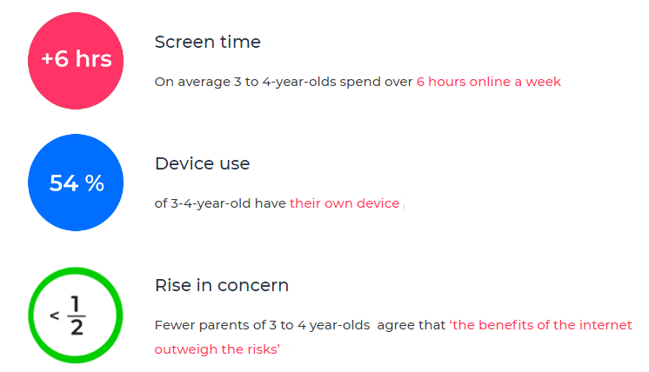
Parent control
Visit: https://www.internetmatters.org/parental-controls/
Many parents can be put off using controls and settings as they think they will be difficult to set up, or complicated to use. Click on the link for step by steps guides, they can help make it simple and straightforward for any device.
You can search parental controls for smartphones and other devices; entertainment & search engines; broadband & mobile networks; social media; and gaming consoles.
Guides to social network, apps and games

Visit: https://www.net-aware.org.uk/

NSPCC NetAware has created simple guides for parents. The guides are for the most popular social networks, apps and games that children are using and what concerns to watch out for
Age Rating
Age restrictions are put in place to stop those under the required age from being exposed to content which is intended for older users. There are two official ways you can check whether a particular game, app or film is appropriate. The BBFC and PEGI can both be used to check the content is appropriate for the child.
The British Board of Film Classification will inform you of the suitability of films and television. The BBFC can also provide additional warnings regarding the content such as language, adult imagery, violence, threat/horror, dangerous behaviour and anything else that might be deemed inappropriate for the child.
https://bbfc.co.uk/
PEGI (Pan European Games Information) is a content rating system that ensures all video games are labelled with a minimum age recommendation. The ratings are split into age restrictions and content descriptors to help parents understand what the game features.
https://pegi.info/
4 types of Risk
Content risks: The child or young person is exposed to harmful material.
Contact risks: The child or young person participates in adult initiated online activity.
Conduct risks: The child or young person is a perpetrator or victim in peer-to-peer exchange.
Commercial risks: The child or young person is exposed to inappropriate commercial advertising (including extremist content), marketing schemes or hidden costs.
Contact: Who do our children need to be aware of?
- Stranger danger: Not everyone online is who they say they are.
- Cyber-bullying in all forms
- Identity theft (including ‘frape’ (hacking Facebook profiles)) and sharing passwords
Content: What do our children need to be aware of?
-Exposure to inappropriate content.
-Ignoring age ratings in games (exposure to violence, offensive language).
Conduct: What do our children need to be aware of?
-Privacy issues, including disclosure of personal information.
-Digital footprint and online reputation
-Screen time
-Being share aware
Commercial: What do our children need to be aware of?
-Issues of advertisements on body image.
-Gambling
-Extremism and radicalisation
-Spam, pop – ups
Useful sites
www.nspcc.org.uk
www.net-aware.org.uk
www.internetmatters.org/
TALK TO SOMEONE ABOUT ONLINE SAFETY
Whether you want to set up parental controls, adjust privacy settings or get advice on social networks, experts from the free O2 & NSPCC helpline are here to help.
0808 800 5002
BBC Own It (Child friendly guidance)
https://www.bbc.com/ownit
Google: Internet Matters (Includes a game children can play based on e-safety)
https://beinternetawesome.withgoogle.com/en_us/

